

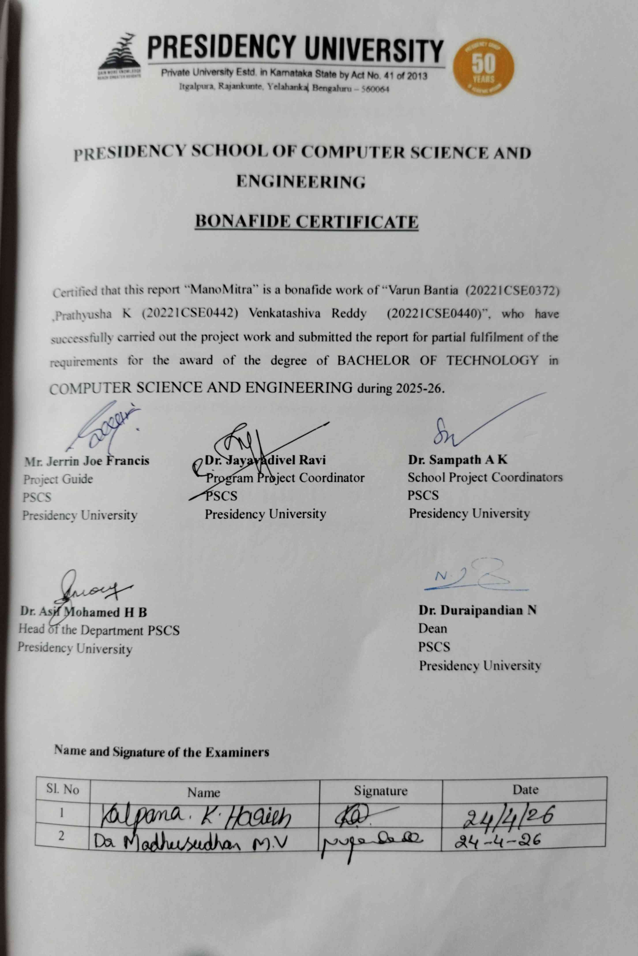





Abstract

Mental health challenges among students have risen sharply due to academic pressure, social expectations, and personal stressors. Despite this growing need, many students hesitate to seek professional help because of stigma, limited awareness, or lack of easy access to mental health resources. Educational institutions also face difficulties in providing timely, scalable, and confidential support systems that can identify and address early signs of emotional distress. However, with the increasing availability of smartphones and advancements in artificial intelligence, there is a strong opportunity to build digital platforms that deliver immediate, accessible, and personalized mental health support.
This project introduces ManoMitra, an AI-powered mental health support platform designed specifically for students. It features an AI-guided first-aid chatbot that offers coping strategies, emotional assistance, and evidence-based self-help techniques. The platform includes a mood tracking module that helps users log daily emotions, allowing the system to identify patterns and provide personalized recommendations such as breathing exercises, meditation, journaling prompts, and motivational content. Additionally, it offers a confidential counselor booking system and a moderated peer-support forum to promote safe community interaction. With regional language support and a secure Android-based backend, the system ensures accessibility, inclusivity, and data privacy. Initial implementation results indicate improved user engagement, quicker access to support during low-mood periods, and enhanced proactive mental health management, making ManoMitra a scalable and cost-effective solution for improving student well-being.

Table of Content

Sl. No. | Title | Page No.
 | Declaration | I
 | Acknowledgement | II
 | Abstract | III
 | List of Figures | VII
 | List of Tables | VIII
 | Abbreviations | IX
1. | Introduction  - Background  - Statistics of project  - Prior existing technologies  - Proposed approach  - Objectives  - SDGs  - Overview of project report | 1  2  3  4  6  7  8
2. | Literature Review | 10
3. | Methodology | 16
4. | Project Management  - Project timeline  - Risk analysis  - Project budget | 22  24  26

5. | Analysis and Design  - Requirements Analysis  - Block Diagram  - Roles and Responsibilites  - System Flow Chart  - Choosing devices  - Design units  - Standards  - Domain model specification  - Communication model  - Functional view  - Operational view  - Other Design aspects | 28  32  35  36  38  39  41  42  45  49  51  54
6. | Hardware, Software and Simulation  - Hardware  - Software development tools  - Software code | 55  57  59
7. | Evaluation and Results  - Test points  - Test plan  - Test result  - Insights | 63  67  71  77
8. | Social, Legal, Ethical, Sustainability and Safety Aspects  - Social aspects  - Legal aspects  - Ethical aspects  - Sustainability aspects  - Safety aspects | 78  79  79  80  81
9. | Conclusion | 83
 | References | 84

 | Base paper | 86
 | Appendix | 87

List of Figures

Figure | Caption | Page No.
Figure 1.1 | Sustainable development goals | 8
Figure 3.1 | Block Diagram of spiral model | 17
Figure 4.1 | Gantt Chart of ManoMitra | 24
Figure 5.1 | Block Diagram of ManoMitra | 32
Figure 5.2 | Flow chart of ManoMitra | 38
Figure 5.3 | Domain Model of ManoMitra | 44
Figure 5.4 | USE Case Model of ManoMitra | 44
Figure 5.5 | Sequence Model of ManoMita | 45
Figure 5.6 | Communication Model of MonaMitra (Request – Response) | 47
Figure 5.7 | Functional View of ManoMitra | 51
Figure 5.8 | Operational view | 53
Figure 7.1 | Booking Page | 73
Figure 7.2 | Chatbot Page | 73
Figure 7.3 | Home Page | 74
Figure 7.4 | Peer Page | 74
Figure 7.5 | Resources Page | 74
Figure 7.6 | Risk Score Distribution | 75
Figure 7.7 | System Response Time Analysis | 75
Figure 7.8 | Decision Boundary Analysis | 76

List of Tables

Table | Caption | Page No.
Table 2.1 | Summary of Reviewed Literature | 12
Table 3.1 | Traceability Mapping | 19
Table 3.2 | Comparison of methodologies | 20
Table 4.1 | Project Timeline | 23
Table 4.2 | External Risk Analysis (PESTLE) | 25
Table 4.3 | Internal Project Risk Matrix | 25
Table 4.4 | Project budget | 26
Table 5.1 | Summarizing Requirements | 31
Table 5.2 | Device selection ManoMitra | 39
Table 5.3 | Description of Domain Model for ManoMitra | 43
Table 7.1 | Comparison of Expected vs Actual Values | 66
Table 7.2 | Functional Test Cases | 69
Table 7.3 | Non - Functional Test Cases | 70
Table 7.4 | Saefty Model Observations | 71
Table 7.5 | System Performance Observations | 72
Table 7.6 | Safety Model Accuracy Metrics | 72
Table 7.7 | Confusion Matrix Results | 73

Abbreviations

Abbreviation | Full Form
AI | Artificial Intelligence
NLP | Natural Language Processing
CBT | Cognitive Behavioral Therapy
DBT | Dialectical Behavior Therapy
API | Application Programming Interface
REST | Representational State Transfer
HTTP | HyperText Transfer Protocol
HTTPS | HyperText Transfer Protocol Secure
TLS | Transport Layer Security
AES-256 | Advanced Encryption Standard (256-bit)
SHA-256 | Secure Hash Algorithm (256-bit)
UID | Unique Identifier
RBAC | Role-Based Access Control
JWT | JSON Web Token
JSON | JavaScript Object Notation
LLM | Large Language Model
TFLite | TensorFlow Lite
ML | Machine Learning
RF | Random Forest
NN | Neural Network
USE | Universal Sentence Encoder
EMA | Ecological Momentary Assessment
RCT | Randomized Controlled Trial
F1 Score | Harmonic Mean of Precision and Recall
PHQ-9 | Patient Health Questionnaire-9
SDG | Sustainable Development Goals
WHO | World Health Organization

DPDP Act | Digital Personal Data Protection Act
PESTLE | Political, Economic, Social, Technological, Legal, Environmental
UAT | User Acceptance Testing
QA | Quality Assurance
CPU | Central Processing Unit
GPU | Graphics Processing Unit
RAM | Random Access Memory
IoT | Internet of Things
IoTWFRM | IoT World Forum Reference Model
SRS | Software Requirement Specification
RTM | Requirement Traceability Matrix
UI | User Interface
UX | User Experience
APK | Android Package Kit
SDK | Software Development Kit
IDE | Integrated Development Environment
AVD | Android Virtual Device

Chapter 1

Introduction

Background

World Health Organization reports that mental health disorders are among the leading causes of disability worldwide, affecting hundreds of millions of people. According to global estimates, approximately one in eight individuals lives with a mental health condition, with anxiety and depressive disorders being the most prevalent. Young adults and adolescents are particularly vulnerable due to academic stress, social pressures, financial uncertainty, and rapid life transitions.
In the Indian context, the burden is equally significant. National Mental Health Survey indicates that nearly 10–14% of the population suffers from some form of mental health disorder, with a substantial treatment gap exceeding 70% in many regions. Furthermore, National Crime Records Bureau data consistently show that students form a considerable proportion of reported suicide cases annually, highlighting the urgency of preventive and early- intervention systems within educational institutions.

Despite increasing awareness, stigma remains a major barrier preventing students from seeking professional help. Limited availability of counselors, long waiting times, fear of judgment, and lack of immediate emotional support mechanisms further aggravate the problem. Traditional counseling systems are often reactive rather than preventive, engaging students only after distress reaches a critical stage.
Simultaneously, rapid advancements in artificial intelligence, mobile computing, and digital health technologies have enabled the development of scalable mental health interventions. AI- based conversational agents, mood-tracking applications, and tele-counseling systems demonstrate potential in providing immediate, confidential, and cost-effective assistance. However, many existing solutions are either generic wellness applications or lack integration within institutional ecosystems.
Therefore, there is a clear need for a structured, AI-powered, student-centric mental health platform that combines real-time emotional support, multilingual accessibility, mood analytics,

and professional referral mechanisms. This project is conceptualized to address this critical gap by leveraging intelligent digital technologies to create an accessible and scalable mental health support infrastructure within educational environments.

Statistics of project
Mental health disorders among young people, especially students, are a growing concern in India and the surrounding region. Recent research indicates that mental health conditions such as stress, anxiety, and depression are highly prevalent in students, with many affected individuals lacking access to timely support and intervention. For instance, studies among Indian school and college students have reported prevalence rates of anxiety and depression ranging from around 40 % to over 60 %, with considerable proportions experiencing moderate to severe symptoms that impact daily functioning and academic performance.
More targeted research among university-aged students across major Indian cities found nearly 70 % of students reporting moderate to high levels of anxiety and about 60 % showing signs of depression, underlining a widespread emotional distress in this demographic. These figures are mirrored in multiple cross-sectional studies where roughly one-half of surveyed students exhibited significant stress and depressive symptoms, indicating that mental health challenges are not isolated incidents but systemic issues within academic environments nationwide.
Nationally, broader surveys estimate that a significant proportion of mental health disorders manifest before the age of 35, with nearly 60 % of all mental illnesses diagnosed in this younger population, emphasizing the critical vulnerability of youth and young adults. Despite such high prevalence, access to professional mental health services remains limited in India, with treatment gaps continuing to exceed 70 % in many regions.
These statistics illustrate a compelling need for interventions that are accessible, scalable, and tailored to the needs of students. Traditional counseling systems within educational institutions are often insufficient due to limited resources, stigma associated with seeking help, and lack of proactive support mechanisms. An AI-powered digital platform like the one proposed in this project can help bridge the gap between student demand and existing mental health support infrastructure, providing immediate emotional support, predictive mood tracking, and confidential pathways to professional help.

Prior Existing Technologies
Digital mental health technologies have evolved rapidly in recent years, leveraging advances in mobile computing, artificial intelligence, and digital communication to expand access to psychological support and therapeutic tools. A major category of existing solutions includes AI-powered conversational agents or chatbots that interact with users through text-based dialogue, providing psychoeducation, evidence-based coping techniques, and self-help exercises. These systems typically integrate machine learning and natural language processing (NLP) to tailor responses in real time, enabling scalable and continuous emotional support without the immediate involvement of a human therapist. Research reviews indicate that such AI chatbots have the potential to deliver 24/7 interaction, reduce stigma associated with help-seeking, and support self-management of stress, anxiety, and depressive symptoms.
Examples of prominent digital mental health platforms incorporating conversational AI include Wysa, which combines an emotionally intelligent chatbot with evidence-based techniques such as cognitive behavioral therapy (CBT) and dialectical behavior therapy (DBT). Wysa also integrates human coaching and multilingual support to broaden its reach across diverse populations. Other implementations of AI chatbots — explored in systematic reviews — show a range of functions from symptom monitoring and personalized recommendations to quasi- therapeutic dialogue rooted in psychological models.
Beyond chatbots, prior digital mental health technologies include tele-therapy and online counseling platforms that connect users with licensed professionals, digital mood-tracking applications that allow self-monitoring of emotional states, and mobile apps that deliver guided relaxation or cognitive exercises. These tools contribute to early recognition and self-care but often lack integrated, intelligent support that adapts to individual emotional profiles.
While existing solutions have shown promise, gaps remain in providing holistic, context- aware, student-centric support that combines real-time AI interaction, predictive mood analysis, culturally sensitive language options, and seamless referral pathways to professional counselors. This project builds upon and extends these prior technologies to deliver a unified, AI-enhanced mental health support system tailored specifically for the needs of students.

Proposed Approach

Aim of the Project

The primary aim of this project is to design and implement ManoMitra, an AI-powered, multilingual mental health support platform tailored for students within academic institutions. The system seeks to provide early emotional intervention, continuous self-monitoring, and structured referral mechanisms to professional counseling services. The platform is designed to be scalable, accessible, confidential, and capable of operating as a first-level psychological support system rather than replacing professional therapy.

Motivation

The motivation behind this project stems from three major challenges observed in student mental health ecosystems:
    - High prevalence of emotional distress among students combined with delayed help- seeking behavior.
    - Stigma and privacy concerns, which discourage students from openly approaching counselors.
    - Limited institutional resources, where counselor-to-student ratios are often insufficient for proactive intervention.
Existing systems are either generic wellness applications or isolated counseling services without predictive or AI-driven early support mechanisms. There is a clear need for a unified, intelligent platform that provides immediate assistance while encouraging professional engagement when necessary.

Implementation Approach

The proposed approach integrates artificial intelligence, mobile application development, and secure backend services to create a structured digital mental health ecosystem.
The system consists of the following core modules:

AI-Guided Emotional First-Aid Chatbot

  - Uses Natural Language Processing (NLP) to understand user input.
  - Provides coping strategies based on evidence-informed psychological frameworks.
  - Detects potential risk indicators and suggests escalation when needed.

Mood Tracking and Pattern Analysis

  - Users log daily emotional states.
  - The system analyzes trends over time.
  - Personalized recommendations are generated based on emotional patterns.

Confidential Booking System

  - Enables students to schedule appointments with institutional counselors.
  - Ensures privacy and secure data handling.

Moderated Peer Support Forum

  - Provides structured peer interaction.
  - Monitored to prevent misinformation or harmful communication.

Multilingual Support

  - Allows content switching into regional languages.
  - Enhances accessibility across diverse student populations.
Technically, the system is developed using Android technologies for frontend implementation, with backend database integration for secure storage and analytics. AI components are embedded to process conversational inputs and mood trends.

Applications of the Project

The proposed system has multiple applications:

  - Educational Institutions – Deployment as a campus mental health support system.
  - Remote and Rural Access – Providing psychological first aid where professional services are scarce.
  - Early Detection Systems – Identifying mood deterioration trends before severe escalation.
  - Workplace Adaptation – Adaptable for corporate employee wellness programs.
  - Research Analytics – Aggregated anonymous data for institutional mental health trend analysis.

Limitations of the Proposed Approach

Despite its advantages, the system has certain limitations:

- AI Interpretation Constraints – NLP models may misinterpret complex emotional nuances.
- Not a Replacement for Therapy – The platform provides first-level support, not clinical diagnosis.
- Data Privacy Risks – Requires robust encryption and compliance with ethical standards.
- Dependence on User Engagement – Effectiveness depends on consistent mood logging and honest responses.
- Digital Divide – Users without smartphones or internet access may not benefit.
These limitations are acknowledged and addressed through ethical safeguards, data security implementation, and clear user disclaimers emphasizing that the platform supplements — not substitutes — professional mental healthcare.

Objectives
The following objectives are defined to be specific, measurable, and demonstrable within the implementation of the ManoMitra AI-based Mental Health Support Platform. These objectives encompass behavioral modeling, analytical processing, system management, security mechanisms, and deployment aspects of the project.

Objective 1: Behavioral Modeling and Interaction

To design and implement an AI-guided conversational module capable of identifying user emotional states through structured natural language input and providing context-aware coping responses based on predefined psychological frameworks.
(Demonstrable through chatbot interaction logs, response classification accuracy, and scenario-based testing.)

Objective 2: Mood Pattern Analysis and Prediction

To develop and integrate a mood tracking system that records daily emotional inputs, performs trend analysis over time, and generates personalized recommendations based on detected emotional patterns.
(Demonstrable through database-stored mood logs, graphical trend visualization, and rule- based recommendation outputs.)

Objective 3: System Management and Integration

To architect and implement a modular Android-based application integrated with a secure backend database to manage user profiles, chatbot interactions, appointment scheduling, and multilingual content switching.
(Demonstrable through functional modules, database connectivity testing, and successful end- to-end workflow execution.)

Objective 4: Security and Data Privacy Implementation

To implement secure authentication, encrypted data storage, and controlled access mechanisms to ensure confidentiality of user data and compliance with digital mental health privacy standards.
(Demonstrable through encrypted storage implementation, secure login authentication, and role-based access control validation.)

Objective 5: Deployment and Scalability

To deploy the application in a real-device Android environment with scalable backend support, ensuring reliable performance under multiple user interactions and institutional-level usage scenarios.
(Demonstrable through APK generation, live device testing, backend response validation, and performance evaluation under simulated concurrent usage.)

SDGS
The ManoMitra AI Mental Health Platform is aligned with the Sustainable Development Goals (SDGs) established by the United Nations (see Fig. 1.1):
- SDG 3 – Good Health and Well-Being: Provides AI-guided emotional first aid, mood tracking, and early intervention support to promote mental well-being among students.
- SDG 4 – Quality Education: Enhances academic performance and retention by addressing psychological barriers that affect student learning.
By improving accessibility to preventive mental healthcare within educational ecosystems, the platform contributes to sustainable social development and institutional well-being.



Figure 1.1: Sustainable development goals

Overview of the Project Report
- Chapter 1 – Introduction: Introduces the project by presenting its background, motivation, objectives, problem statement, and alignment with the United Nations Sustainable Development Goals (SDGs).
- Chapter 2 – Literature Review: Provides a comprehensive and critical review of academic research and existing technologies related to conversational AI, digital mental health systems, mood analytics, and multilingual platforms.
- Chapter 3 – Methodology: Describes the research methodology, including system design strategy, selected tools and technologies, development processes, and justification of the chosen approach.
- Chapter 4 – System Architecture and Design: Explains the overall system architecture, algorithms, data flow diagrams, and operational flowcharts that define the structural and functional framework of the platform.

- Chapter 5 – Implementation: Details the development of the system, including frontend implementation (Android), backend development (Node.js), database integration, API connectivity, and security mechanisms.
- Chapter 6 – Results and Evaluation: Presents system performance evaluation using measurable metrics such as response accuracy, processing latency, usability analysis, and user satisfaction assessment.
- Chapter 7 – Social, Legal, Ethical, and Sustainability Considerations: Discusses ethical implications, privacy protection measures, regulatory considerations, risk assessment, and long-term sustainability impact.
- Chapter 8 – Future Scope and Recommendations: Outlines potential enhancements, scalability improvements, advanced AI integration, and deployment expansion strategies.
- Chapter 9 – Conclusion: Summarizes the overall findings of the project, highlights key achievements, acknowledges limitations, and provides final remarks on the system’s effectiveness and contribution.

Chapter 2

Literature review

2.1 Review of Related Literature
- Fitzpatrick et al. (2017) conducted one of the early randomized controlled trials evaluating a fully automated conversational agent delivering cognitive behavioral therapy (CBT) techniques to young adults. The system utilized rule-based dialogue management combined with scripted CBT interventions. Their study demonstrated statistically significant reductions in depressive symptoms over a short intervention period. However, the chatbot relied heavily on predefined responses and lacked contextual understanding of complex emotional expressions. The study acknowledged that conversational depth and personalization were limited. This highlights the need for improved NLP-driven emotional interpretation, which our project addresses by integrating dynamic mood tracking alongside chatbot responses.
- Inkster et al. (2018) evaluated the effectiveness of an AI mental health chatbot offering mood reflection and resilience-building exercises. The system incorporated machine learning techniques to adapt responses based on user sentiment classification. Results indicated high user engagement and moderate symptom improvement. However, the study reported challenges in handling crisis-level interactions and emphasized the need for structured escalation mechanisms. This gap informs our implementation of referral and booking modules for professional counselor intervention.
- Calvo et al. (2020) reviewed computational models used in affective computing for mental health applications. The authors examined sentiment analysis, emotion recognition, and linguistic feature extraction techniques. They concluded that hybrid approaches combining lexical analysis with contextual embeddings outperform purely rule-based systems. However, they noted inconsistencies in emotional labeling datasets and the lack of culturally adaptive models. Our platform addresses this by integrating multilingual switching to reduce linguistic bias.
- Miner et al. (2016) analyzed risks associated with conversational agents in healthcare. The paper discussed ethical issues, misinterpretation of user intent, and safety limitations. Although conversational AI improves accessibility, insufficient validation of clinical claims may cause

harm. This study influenced our design decision to position the chatbot as “first-level support” rather than a diagnostic system.
- Saeb et al. (2015) investigated smartphone-based mood sensing using passive data such as location and phone usage patterns. Their predictive modeling demonstrated correlations between behavioral patterns and depressive symptoms. However, privacy concerns and data consent complexities were identified as major limitations. In contrast, our approach uses voluntary self-logged mood inputs to minimize invasive data collection.
- Wang et al. (2018) studied long-term mood tracking through mobile ecological momentary assessment (EMA). The research showed that frequent mood logging improves predictive modeling accuracy but also increases user fatigue. This trade-off informs our design choice of simplified daily logging rather than high-frequency prompts.
- Joshi et al. (2020) examined multilingual NLP challenges in low-resource languages. The paper emphasized model bias toward English datasets and the need for inclusive design in AI systems. Our platform incorporates full-language switching rather than partial translation within modules to maintain consistency.
- Khurana et al. (2021) explored AI systems designed for rural healthcare access. The findings highlighted that localized language support significantly increased adoption rates. However, scalability issues were observed due to infrastructure limitations. This supports our cloud-based backend approach for institutional scalability.
- Bickmore et al. (2010) presented relational agents in healthcare environments, focusing on user engagement through human-like interaction. While engagement improved, computational complexity and maintenance overhead were substantial. Our system balances personalization with lightweight Android deployment architecture.
- Abd-alrazaq et al. (2019) conducted a systematic review of AI chatbots in healthcare. They found that most systems lack standardized evaluation metrics and often measure engagement rather than clinical improvement. This gap informs our inclusion of measurable parameters such as response latency, accuracy testing, and structured usability evaluation.
- Fulmer et al. (2018) evaluated a text-based conversational agent designed to deliver mental health support using principles of cognitive behavioral therapy and positive psychology. The system focused on brief, daily interactions to improve user mood and emotional awareness. Their findings showed increased user engagement and short-term improvements in self-

reported well-being. However, the study highlighted limitations in handling complex or severe mental health conditions, as the chatbot lacked deep contextual reasoning. This reinforces our system’s design approach of combining chatbot support with escalation pathways such as counselor booking for high-risk cases.
- Gaffney et al. (2019) conducted a systematic review on the effectiveness of smartphone- based mental health interventions, including chatbots and self-help applications. The study found that digital interventions can provide accessible and cost-effective support, especially for mild to moderate symptoms of anxiety and depression. However, issues such as user retention, long-term effectiveness, and lack of personalization were identified as key challenges. This insight influenced our implementation of personalized recommendations through mood tracking and adaptive response generation to improve sustained user engagement.
Summary of Literatures reviewed
Table 2.1 Summary of Literature reviews

Paper | Domain | Architect ure | Dataset | Strengths | Limitation s | Performa nce
Auerbach et al.,  WHO  World Mental Health Surveys | Student Mental Health Epidemiol ogy | Cross- national survey analysis using DSM-  based instrumen ts | WHO  surveys across 21 countries | Large- scale, globally representati ve; identifies unmet mental health needs | No intervention or real-time system | Descriptiv e prevalenc e statistics
Firth et al., Smartpho  ne-based | Mobile Mental Health | App- based CBT &  self-help | RCTs  across  clinical & university | Evidence- based effectivene | Limited personalizat ion; no | Moderate reduction in

interventi ons |  | interventi on framewor k | population s | ss of mobile apps | crisis detection | depressive symptoms
Inkster et al., Empathy- driven AI | Conversati onal AI for Mental Health | Rule- based + NLP-  driven chatbot | Controlled conversati onal trials | Demonstrat es empathetic AI  interaction | No deep learning; weak escalation | Improved engageme nt (qualitativ e)
Fitzpatric k et al., Woebot | CBT-based Mental Health Chatbot | Rule- based CBT  chatbot | College students (RCT) | Clinically validated CBT  delivery | No suicide risk detection | Reduced depressio n scores (PHQ-9)
Nikhiles war et al., ICOSEC | Suicide Risk Detection | USE +  Fully Connecte d Neural Network | Reddit SuicideWa tch dataset (Kaggle) | High accuracy; lightweight ML model | Social media bias; not a  support system | Accuracy  ≈ 93%, F1  ≈ 0.92
Mental health of students in higher education | Policy & Systems | Institution al framewor k analysis | Global higher- education reports | Identifies systemic gaps & stigma | No technical implementa tion | Policy insights
Abd- Alrazaq et al.,  Chatbots for mental health | AI  Chatbots | Review of rule-based & ML chatbots | 41 studies across platforms | Comprehen sive overview of chatbot benefits | Highlights lack of crisis handling | Review (no metrics)

Bull et al., Human- in-the- loop ML | Clinical ML for Risk Detection | ML +  clinician- in-the- loop framewor k | Medical & administra tive records | High accuracy, human oversight | Not real- time; structured data only | Accuracy  ≈ 94.7%
Juanita et al., ML for mental health text diagnosis | ML/NLP  for Mental Health | Gradient Boosting, RF, NN + NLP  features | Online doctor consultatio ns (15k samples) | Strong comparativ e ML  evaluation | Not conversatio nal; no chatbot | Accuracy  ≈ 84%, F1  ≈ 0.86
Olla et al., Luna Mental Health Chatbot | AI-  powered Student Mental Health | Safety- first LLM chatbot with rule- based escalation | Deployed in higher education | Real-world deployment  ; ethical safeguards | Limited ML training; depends on pretrained LLM | Positive user acceptanc e
Fulmer et al. (2018) | Conversati onal AI for Well-being | Text- based chatbot using CBT &  positive psycholog y | Controlled user interaction studies | Improves short-term well-being; high engagemen t | Limited handling of severe mental health cases | Moderate improvem ent in  mood scores
Gaffney et al.  (2019) | Digital Mental Health | Systemati c review of mobile & | Multiple studies across platforms | Accessible and cost- effective solutions | Low long- term retention; limited | Mixed outcomes across studies

 | Interventio ns | chatbot- based interventi ons |  |  | personalizat ion

Research Gap and Implementation

Gap 1: Existing mental health apps often provide only single features such as chatbot support or mood tracking, lacking a unified platform.
Gap 2: Many chatbot systems do not have safety mechanisms to detect suicidal thoughts, self- harm intent, or crisis situations.
Gap 3: Most systems depend completely on cloud processing, causing higher latency and privacy risks.
Gap 4: Existing solutions rarely provide smooth transition from AI support to professional human counseling.
Gap 5: Many platforms are designed mainly for English-speaking users and lack multilingual accessibility.
Gap 6: Conventional mental health systems do not provide role-based management for institutions.
Gap 7: Many applications lack emotional trend monitoring and long-term wellness insights.

Chapter 3

Methodology

Selected Methodology: Spiral Model
The Spiral Model, proposed by Boehm (1988), is selected as the development methodology for the ManoMitra AI-based Mental Health Support Platform. The Spiral Model integrates iterative development with systematic risk analysis, making it particularly suitable for projects involving high-risk components, evolving requirements, and emerging technologies such as Artificial Intelligence and Natural Language Processing (NLP).
Unlike linear models such as Waterfall, which assume stable requirements, the Spiral Model supports continuous refinement through repeated cycles (spirals), each comprising planning, risk assessment, engineering, and evaluation. AI-driven conversational systems are inherently probabilistic, context-sensitive, and adaptive. Therefore, requirements evolve based on:
    - User interaction patterns

    - Emotional response accuracy

    - Performance feedback

    - Security assessments

    - Institutional compliance needs

The Spiral Model enables incremental enhancement of chatbot intelligence, mood analytics accuracy, and system security without destabilizing the overall architecture.

Reference:
Boehm, B. (1988). A Spiral Model of Software Development and Enhancement. ACM SIGSOFT Software Engineering Notes, 11(4), 14–24.

Illustrative Block Diagram of Methodology

Below is a conceptual Spiral Model diagram adapted for ManoMitra:
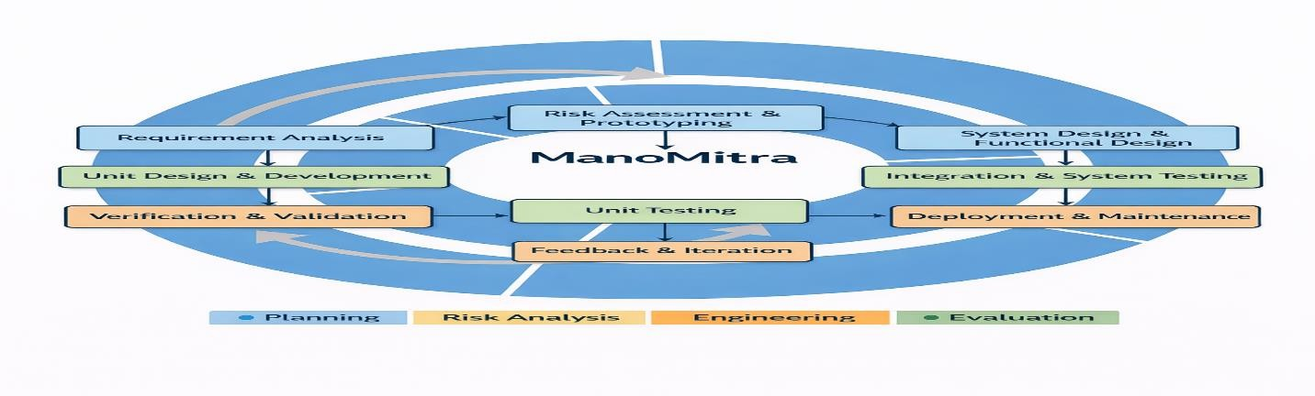

Figure 3.1: Block Diagram of spiral model

Spiral Model Phases Applied to ManoMitra
The development of ManoMitra follows the Spiral Model, where each iteration is structured around four key stages: planning, risk analysis, engineering, and evaluation. This iterative approach allowed the system to evolve through continuous refinement, particularly during critical components such as chatbot development and multilingual support. By revisiting each phase multiple times, the project ensured gradual improvement in accuracy, usability, and system reliability while addressing emerging challenges

Planning (Requirement Analysis & Specification)

The planning phase focused on systematic requirement gathering and analysis to define the foundation of the system. Inputs were collected from an extensive literature review, institutional mental health requirements, and the identification of both functional and non- functional system needs. The functional requirements included features such as AI-based conversational emotional support, mood tracking with historical trend analysis, appointment booking with counselors, multilingual switching, and secure authentication mechanisms. In addition, non-functional requirements were carefully defined to ensure system performance

and reliability, including maintaining response latency below two seconds, ensuring secure data storage through encryption, achieving high availability, enabling scalability, and complying with user privacy standards. The primary deliverables of this phase were the Software Requirement Specification (SRS) and the Requirement Traceability Matrix (RTM), which served as structured references for subsequent development stages.

Engineering (System & Unit Design)

The engineering phase focused on transforming the defined requirements into a structured and functional system design. At the architectural level, the system was built using an Android- based frontend to ensure accessibility for students, supported by a Node.js backend responsible for handling logic, requests, and integrations. Data storage was managed using MongoDB or Firebase to ensure flexibility and scalability, while NLP and LLM APIs were integrated to enable intelligent conversational capabilities. A secure authentication mechanism was also implemented to protect user data and maintain privacy. Alongside the system architecture, a modular design approach was adopted, where individual components such as the chatbot module, mood analytics module, booking module, multilingual engine, and authentication module were developed independently. This separation of concerns minimized interdependencies between components, reduced system complexity, and significantly improved maintainability and scalability of the platform..

Evaluation (Testing & Validation)

The evaluation phase ensured that the system met both technical specifications and user expectations through a combination of verification and validation processes. Verification activities focused on confirming that each component functioned correctly at a technical level, including unit testing of chatbot logic, API testing using tools like Postman, database integrity checks, and validation of encryption mechanisms for secure data handling. In parallel, validation activities assessed the system from a user perspective, including user acceptance testing, evaluation of response relevance from the chatbot, measurement of system latency, and collection of user satisfaction feedback through surveys. Each iteration of the spiral cycle incorporated insights from these evaluations, leading to continuous refinement of chatbot responses, reduction in response time, and overall improvement in user experience and system reliability.

Technical Justification for Spiral Model
The Spiral Model is technically superior for this project due to the following reasons:

AI Systems Are Non-Deterministic

Conversational AI produces probabilistic outputs. Initial responses may require refinement based on user feedback. Spiral allows iterative correction.

High Risk in Mental Health Domain

Mental health applications require strict risk mitigation. Spiral includes formal risk analysis at every iteration.

Requirement Evolution

User expectations evolve after interacting with early prototypes. Spiral supports requirement modification.

Experimental Nature of NLP

Language models may behave unpredictably. Iterative experimentation ensures performance stability.

Security Sensitivity

Privacy-related risks must be continuously evaluated. Spiral integrates security assessment within each iteration.

Traceability Mapping
To ensure requirement coverage, a Requirement Traceability Matrix was implemented.

Table 3.1: Traceability Mapping

Requirement | Design Module | Testing Phase
AI Emotional Support | Chatbot Module | Unit + System Testing
Mood Logging | Mood Module | Integration Testing
Booking System | Booking Module | System Testing
Multilingual Support | Language Module | Validation Testing

Secure Login | Auth Module | Security Testing
This ensures no requirement remains untested.

Comparison with Alternative Methodologies
Table 3.2: Comparison of methodologies

Methodology | Limitation for This Project
Waterfall | Inflexible to AI refinement
V-Model | Less adaptive to evolving AI logic
Agile | Less formal risk documentation
DevOps | Focuses on deployment, not risk-driven design

Iteration Example in Project

Iteration 1:

    - Basic chatbot with rule-based responses.

Iteration 2:

    - NLP-based response improvement.

Iteration 3:

    - Multilingual integration.

Iteration 4:

    - Mood trend analytics enhancement.

Iteration 5:

    - Security strengthening & performance optimization.

Each iteration followed planning → risk → engineering → evaluation.

Conclusion of Methodology
The Spiral Model ensures:

    - Continuous refinement of AI accuracy.

    - Structured risk mitigation.

    - Requirement traceability.

    - Secure system evolution.

    - Scalable architecture.

Given the high-risk AI integration, emotional sensitivity of domain, and evolving requirements, the Spiral Model provides the most technically justified and academically robust methodology for ManoMitra.

Chapter 4

Project Management

Project Timeline
The development of ManoMitra followed a structured five-month academic timeline, covering planning, development, testing, and deployment phases. The timeline was carefully designed to ensure systematic execution of tasks, proper milestone tracking, and efficient coordination among team members. Each activity was assigned a specific duration, dependency, and responsible team to maintain smooth workflow throughout the project lifecycle. This planned approach helped in completing the project within the scheduled time while maintaining quality standards.
The project was divided into four major phases: Planning & Design, Development, Testing, and Deployment. In the Planning & Design phase, the initial focus was on understanding the project requirements and conducting a literature review related to AI-driven mental health systems. This activity was carried out from 05-Jan-26 to 18-Jan-26 under Task ID T1. After gathering requirements, the system architecture and functional design were prepared from 19- Jan-26 to 01-Feb-26 (Task T2). During the same period, UI/UX design and prototyping were also initiated from 19-Jan-26 to 08-Feb-26 (Task T3) to create an intuitive and user-friendly mobile application interface.
The Development phase started after completion of the design tasks. Backend development, including API creation and AI model integration, was carried out from 02-Feb-26 to 08-Mar- 26 (Task T4). Frontend development for the Android user interface was performed from 02- Feb-26 to 15-Mar-26 (Task T5). In parallel, database setup and authentication modules were implemented from 02-Feb-26 to 22-Feb-26 (Task T6). These tasks ensured that both technical infrastructure and user-facing components were developed simultaneously for faster progress. Once development activities were completed, the project entered the Testing phase. Integration and system testing were conducted from 16-Mar-26 to 29-Mar-26 (Task T7) to verify the interaction between frontend, backend, and AI modules. After successful internal testing, User Acceptance Testing (UAT) was performed from 30-Mar-26 to 05-Apr-26 (Task T8) to validate usability and gather feedback for improvements.
The final phase was Deployment, where bug fixes and performance optimization were completed from 06-Apr-26 to 19-Apr-26 (Task T9). After resolving issues and enhancing system efficiency, the final deployment and documentation phase was scheduled from 20-Apr-

26 to 10-May-26 (Task T10). This stage included final report preparation, user manuals, and submission readiness.
Overall, this phased timeline ensured organized progress, timely completion of deliverables, and successful execution of the ManoMitra project.
Table 4.1: Project Timeline

Phase | Tas  k ID | Task | Star  t | End | Duratio  n | Dependencie  s | Assigne  e
Planning & Design | T1 | Requirement Analysis & Literature  Review | 05-  Jan- 26 | 18-  Jan- 26 | 2 | – | Project Lead
 | T2 | System Architecture & Functional  Design | 19-  Jan- 26 | 01-  Feb- 26 | 2 | T1 | Design Team
 | T3 | UI/UX Design & Prototyping | 19-  Jan- 26 | 08-  Feb- 26 | 3 | T1 | Fronten d Team
Developmen t | T4 | Backend Development (API & AI  Integration) | 02-  Feb- 26 | 08-  Mar- 26 | 5 | T2 | Backend Team
 | T5 | Frontend  Development (Android UI) | 02-  Feb- 26 | 15-  Mar- 26 | 6 | T3 | Fronten d Team
 | T6 | Database & Authentication Implementatio  n | 02-  Feb- 26 | 22-  Feb- 26 | 3 | T2 | Backend Team
Testing | T7 | Integration & System Testing | 16-  Mar- 26 | 29-  Mar- 26 | 2 | T4, T5 | QA  Team

 | T8 | User Acceptance  Testing (UAT) | 30-  Mar- 26 | 05-  Apr- 26 | 1 | T7 | QA  Team
Deployment | T9 | Bug Fixes &  Performance Optimization | 06-  Apr- 26 | 19-  Apr- 26 | 2 | T8 | Dev Teams
 | T10 | Final Deployment & Documentatio  n | 20-  Apr- 26 | 10-  May  -26 | 3 | T9 | Project Lead
This phased timeline ensured structured progress and milestone tracking.
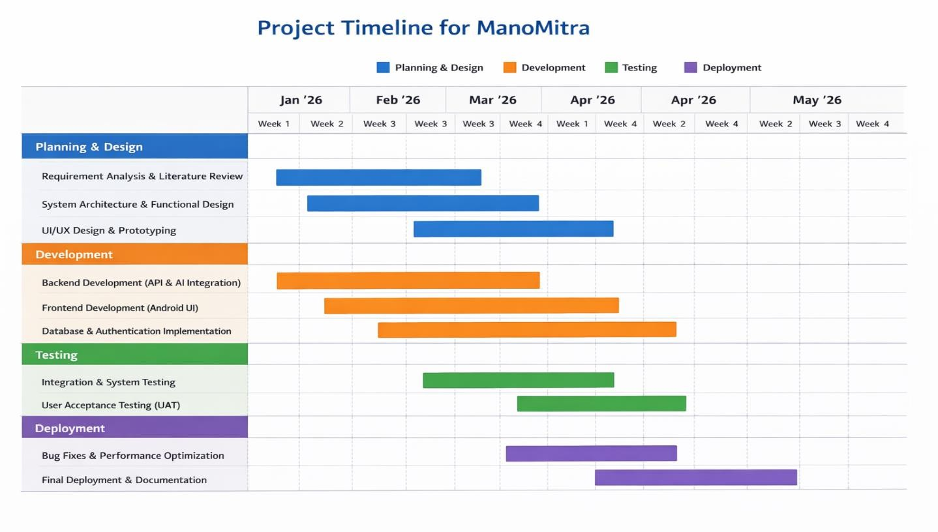
Figure 4.1 Gantt Chart of ManoMitra

Risk Analysis
Given the sensitive nature of mental health data and AI-driven interaction, proactive risk management is essential. Both macro-environmental (PESTLE) and internal project risks were analyzed.

PESTLE Analysis
Table 4.2: External Risk Analysis (PESTLE)

Factor | Potential Risks for ManoMitra | Mitigation Strategies
Political | Changes in data protection regulations (e.g., India’s DPDP Act 2023) may require stricter  compliance. | Implement “privacy by design.” Encrypt data and design modular architecture to adapt to regulatory  updates.
Economic | Budget limitations may restrict advanced AI API usage. | Use optimized API calls, caching mechanisms, and free student cloud  credits.
Social | Stigma around mental health may reduce user adoption. | Ensure anonymity, confidentiality,  and clear communication about privacy.
Technological | Over-reliance on third-party AI APIs could disrupt service if  pricing or availability changes. | Use modular AI connectors allowing alternate model integration.
Legal | Risk of AI giving inappropriate emotional advice. | Include disclaimers and escalation to  human counselors. Avoid clinical diagnosis claims.
Environmental | Energy consumption of AI data centers. | Utilize major cloud providers committed to renewable energy  usage.

Project Risk Matrix
Table 4.3: Internal Project Risk Matrix

Risk Category | Specific Risk | Likelihood | Impact | Mitigation Plan
Technical | AI misinterprets emotional distress | Medium | High | Implement keyword escalation rules and  human referral system
Technical | High API latency affects user  experience | Medium | Medium | Implement caching and optimize backend queries

Security | Data breach of sensitive mood logs | Low | Very High | Encrypt data, secure authentication, HTTPS  APIs
Ethical | Inappropriate chatbot advice  during crisis | Low | Critical | Include crisis helpline integration and warning  prompts
Project  Management | Scope creep due to  feature expansion | High | Medium | Define MVP and freeze  features post design phase
Timeline Risk | Academic deadline  constraints | Medium | High | Weekly review meetings  and buffer weeks
External | AI API service  downtime | Low | High | Backup response system  and retry logic

This structured matrix ensures early identification and mitigation of critical risks.

Project Budget
As an academic project, ManoMitra utilizes student resources and free-tier services.
Table 4.4: Project Budget

Category | Item | Cost Breakdown  (INR) | Total  (INR)
A. Personnel Costs | Student Development Team | Academic Project | ₹0
 | Subtotal |  | ₹0
B. Software &  Infrastructure | Cloud Hosting  (Firebase/Serverless) | Free Student Tier | ₹0
 | AI API Usage (Projected) | Estimated based on  testing usage | ₹1,200
 | Development Tools | Free Educational  Licenses | ₹0
 | Subtotal |  | ₹1,200
C. Overheads | College Infrastructure | N/A | ₹0
 | Subtotal |  | ₹0

Total Estimated Budget Total Direct Cost: ₹1,200 Key Budget Assumptions
    - Student team (no salary cost)
    - Use of free educational cloud credits
    - Limited AI API calls during academic testing
    - College infrastructure for development and testing

Chapter 5

Analysis and Design
Analysis and design are fundamental and interconnected phases in system development. Analysis focuses on understanding the problem domain, identifying user needs, and defining system requirements (“what the system must do”), whereas design focuses on constructing a technical and structural solution (“how the system will achieve it”).
In the context of the ManoMitra AI-based Mental Health Support Platform, the analysis phase examined student mental health challenges, system expectations, constraints, and regulatory considerations. The design phase translated these requirements into modular architecture, database structures, API integrations, and interface workflows.

Requirements Analysis
This phase captures the purpose, behaviour, and system requirements of ManoMitra.

System Purpose

ManoMitra is an AI-powered mental health support platform developed to provide accessible and immediate emotional assistance to students. The system is designed to offer AI-guided emotional first aid through conversational interaction, enable mood tracking with behavioral analysis, and facilitate confidential booking of professional counseling sessions. Additionally, it incorporates multilingual accessibility to ensure inclusivity and implements secure data management practices to protect user information and maintain privacy.

System Behaviour

The system operates through multiple functional behaviors that work together to deliver comprehensive support. It enables conversational interaction where the AI chatbot communicates with users and provides context-aware emotional guidance. The mood tracking functionality allows users to log their daily emotional states, which are then analyzed to identify patterns over time. The system also includes an escalation mechanism that detects crisis-related keywords and recommends professional intervention when necessary. Furthermore, multilingual capabilities allow users to dynamically switch languages across all modules, ensuring a consistent and inclusive user experience.

Functional Requirements

The functional requirements define the core services that ManoMitra must perform. The system shall provide secure user registration and login, AI chatbot interaction, mood logging and history visualization, multilingual language switching, and confidential counselor appointment booking. It shall also support crisis keyword detection, emergency escalation recommendations, push notifications or reminders, and role-based dashboards for students, counselors, and administrators. Data generated through user interaction shall be stored securely and synchronized with the backend in real time.

Non-Functional Requirements

The non-functional requirements specify quality attributes of the system. The platform must provide chatbot response latency below two seconds under normal conditions and maintain reliable service availability. It should be scalable to support multiple concurrent users and optimized for Android devices with moderate hardware resources. Security measures such as encrypted storage, HTTPS communication, token-based authentication, and privacy- preserving on-device inference must be ensured. The application should also be user-friendly, responsive across different screen sizes, and accessible to diverse users.

System Hardware Requirement Phase

Although ManoMitra is primarily a software-based system, the hardware environment plays an important role in its operation. The system assumes the availability of an Android smartphone or a web-accessible device with a stable internet connection, along with access to a cloud hosting environment. Inputs to the system include user text messages, mood selections, authentication credentials, and booking requests. Based on these inputs, the system generates outputs such as chatbot responses, visualized mood trends, appointment confirmations, and language-adapted interfaces. The internal processing follows defined relationships, where user inputs are passed through NLP processing to generate AI-driven responses, mood logs are stored and analyzed for trend computation, and booking requests are validated before confirmation. However, the system must operate within certain constraints, including limitations of mobile device memory, dependence on internet connectivity, API rate limits, and the need to optimize battery consumption.

System Software Requirement Phase

The software requirements focus on ensuring smooth backend operations and seamless system integration. The system assumes that the backend server is operational, API keys are properly configured, and database connectivity is established. Inputs at this stage include JSON-based API requests, chat message payloads, mood data entries, and user language preferences. The system processes these inputs to generate structured chatbot responses, securely store mood logs, maintain authenticated user sessions, and render multilingual content. The processing flow follows defined relationships, where REST APIs interact with backend logic and databases, and NLP engines perform sentiment detection to guide response generation. The system must also adhere to constraints such as maintaining response latency below two seconds, ensuring secure HTTPS communication, implementing token-based authentication, and handling errors effectively in cases of API failure.

Data Collection Requirements

The system collects data in a controlled and ethical manner to support its functionality while maintaining user privacy. The collected data includes anonymized user chat logs, mood entries, booking records, and non-sensitive usage analytics. Data collection is strictly based on user consent, with an emphasis on minimizing stored information and avoiding any form of passive or intrusive tracking. This ensures that the platform remains privacy-conscious while still enabling meaningful insights.

Data Analysis Requirements

Data analysis plays a key role in enhancing system intelligence and personalization. The system performs mood trend computation to identify behavioral patterns over time and uses sentiment classification to interpret user emotions during interactions. It also evaluates the relevance of chatbot responses to improve conversational quality and measures system latency to ensure performance efficiency. These analytical processes contribute to continuous system improvement and more accurate support delivery.

System Management Requirements

Effective system management is essential for maintaining reliability and performance. The platform includes an administrative dashboard that allows monitoring of system activities and user interactions. It supports API key management, logging mechanisms, and audit trails to

track system operations. Additionally, backup and recovery mechanisms are implemented to ensure data integrity and system continuity in case of failures or unexpected issues.

Security Requirements

Security is a critical aspect of the ManoMitra platform, given the sensitivity of mental health data. The system ensures encrypted storage of user data and employs secure authentication mechanisms such as JWT or Firebase Authentication. All communications are conducted over HTTPS to prevent data interception, and role-based access control is implemented to restrict unauthorized access. The system also includes crisis-response disclaimers to clearly define the scope and limitations of the AI support, ensuring ethical and responsible usage.

User Interface Requirements

The user interface is designed to be simple, calming, and user-friendly to enhance engagement and reduce cognitive load. It emphasizes intuitive navigation so that users can easily access different features without confusion. Accessibility considerations are incorporated to ensure usability for a diverse range of users, and multilingual support is seamlessly integrated into the interface. Overall, the design prioritizes clarity, comfort, and ease of interaction to create a supportive digital environment for users.
Table 5.1: Summarizing Requirements

Category | Specification
Purpose | Provide AI-based emotional support and mood analytics
Functional | Chatbot, Mood tracking, Booking system, Alerts
Non-Functional | Performance, Security, Scalability, Usability
Behaviour | Conversational AI, Mood tracking, Booking system
System Management | Admin monitoring, secure authentication
Data Analysis | Mood trend computation and sentiment detection
Deployment | Cloud-based, Android accessible
Security | Encryption, HTTPS, secure login

Block diagram
The functional block diagram illustrates the flow of data and processing in the ManoMitra Mental Health Support System. It is organized into three primary sections Input, Processing, and Output—demonstrating how user interactions are transformed into intelligent, secure, and supportive responses. Figure 5.1 represents the functional architecture of ManoMitra, highlighting the integration of multiple system modules working together seamlessly.
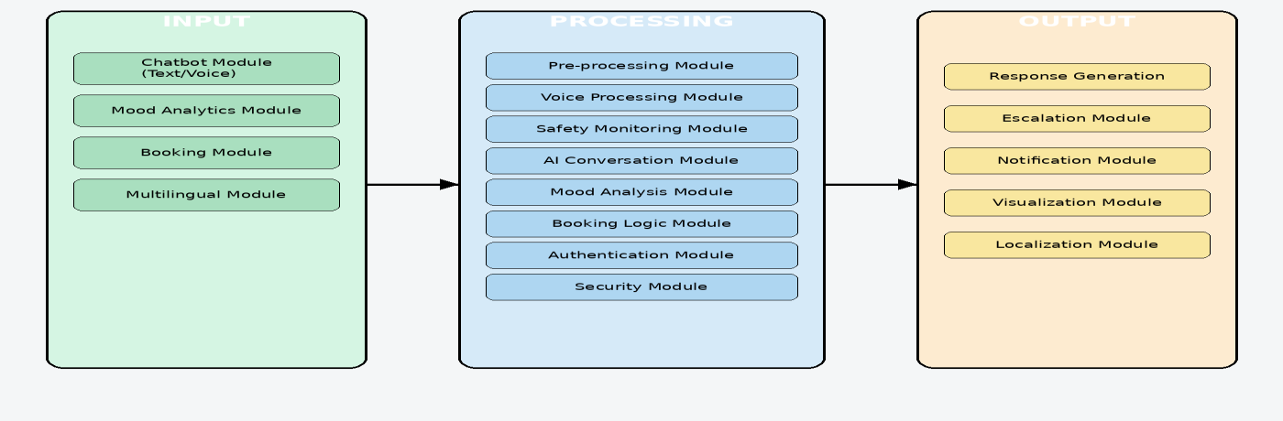

Fig 5.1 Block Diagram

Input Layer

The input layer acts as the user interaction gateway where users provide information to the system through multiple channels. It is designed to be user-friendly, accessible, and inclusive for different user needs.

Chatbot Input Module

This module allows users to communicate with the system using text or voice messages. Users can describe emotions, stress, anxiety, or general concerns, which are then forwarded for processing.

Mood Analytics Input Module

Users can record their daily emotional state by selecting moods such as happy, stressed, anxious, calm, or sad. These inputs help the system track emotional trends over time.

Self-Assessment Questionnaire Module
This module collects responses to mental wellness questionnaires. The answers are used to evaluate the user’s emotional condition and provide guidance or recommendations.

Booking Request Module

Users can request appointments for counseling or professional support services. Booking details are securely passed to the appointment management system.

Multilingual Preference Module

Users can select their preferred language for communication. This improves accessibility and enables interaction in regional or familiar languages.

Processing Layer

The processing layer is the intelligence core of ManoMitra. It analyzes user inputs, applies AI models, performs safety checks, and generates suitable outputs.

Input Pre-processing and Validation Unit

This module cleans incoming data by removing errors, unwanted characters, or invalid entries. It also validates the input format to ensure system security and proper processing.

Voice Processing Unit

Speech-based inputs are converted into text using speech recognition techniques. This enables users to interact naturally through voice commands.

Safety Monitoring Module

This is one of the most critical modules of ManoMitra. It uses on-device intent classification and keyword analysis to detect high-risk emotional states such as self-harm, suicidal thoughts, or crisis language. If risk is detected, the system immediately triggers safety protocols.

AI Conversation Engine

The AI Conversation Engine processes validated text inputs and generates empathetic, context- aware responses using Natural Language Processing (NLP) and Large Language Model (LLM) integration. It ensures supportive and human-like communication.

Mood Analytics Engine

This module analyzes historical mood entries to identify emotional trends, recurring stress patterns, and behavioral changes. Based on these patterns, personalized wellness suggestions can be generated.

Booking Management Module

The system processes appointment requests, checks availability, and generates secure anonymous reference IDs for each booking. This protects user identity during scheduling.

Authentication and Access Control Module

This module manages user login, session control, and permissions using Role-Based Access Control (RBAC). Different roles such as user, counselor, and admin receive controlled access to specific functionalities.

Security and Encryption Module

Sensitive data such as passwords and personal information are protected using encryption and hashing techniques like SHA-256. This ensures confidentiality and secure data storage.

Output Layer

The output layer delivers processed information back to the user in a meaningful, secure, and supportive format.

AI-Based Supportive Responses

The chatbot provides personalized mental health support responses in text or voice format based on the conversation context.

Crisis Escalation Guidance

If the Safety Monitoring Module detects high-risk intent, the system provides emergency guidance, helpline suggestions, or encourages immediate professional support.

Appointment Confirmation

After successful booking, users receive appointment confirmation along with a non-identifiable reference ID for privacy protection.

Mood Trend Visualization

The Mood Analytics Module displays emotional trends through graphs, summaries, or progress indicators to help users understand their mental wellness journey.

Localized Language Responses

The system presents outputs in the user’s selected language, improving comfort and accessibility.

Secure Notifications

The Notification Module sends reminders, booking alerts, wellness prompts, or follow-up messages through secure in-app notifications.

Summary

The modular functional architecture of ManoMitra ensures that every user interaction is securely captured, intelligently processed, and meaningfully responded to. By combining AI conversation support, emotional risk detection, mood tracking, multilingual accessibility, and secure appointment booking, the system provides a comprehensive digital mental health support platform.

Roles and Responsibilites

Varun – Software Developer

      - Developed the core application logic and backend modules.

      - Managed database integration and API development.

      - Performed testing, debugging, and deployment activities.

      - Ensured system security and performance optimization.

      - Coordinated technical implementation of project features.

Venkat – Front End Developer

      - Designed and developed responsive user interface screens.

      - Implemented interactive components for better user experience.

      - Integrated frontend modules with backend services.

      - Improved navigation flow and application usability.

      - Tested UI compatibility across multiple devices.

Prathyusha – UI/UX Designer

      - Created wireframes, prototypes, and design concepts.

      - Focused on user-friendly layouts and visual consistency.

      - Selected color themes, typography, and design elements.

      - Improved accessibility and overall user satisfaction.

      - Worked closely with developers to implement final designs.

System Flow chart
The system flowchart (Figure 5.2) visualizes the complete operational workflow of the ManoMitra Mental Health Support System, clearly showing initialization, decision points, processing stages, outputs, and the feedback loop.
The flow proceeds as follows:

Start:
The process begins when the user launches the ManoMitra application.

Initialization:
The system initializes essential services such as authentication session check, language preferences, AI configuration, and secure database connectivity.

Authentication:
The user either logs in, signs up, or continues anonymously. Role-based permissions are assigned at this stage.

Input:
The user provides input in the form of:

      - Text message

      - Voice query

      - Mood selection

      - Questionnaire response

      - Booking request

Processing:
The system performs multiple internal operations:

      - Voice input is converted into text.

      - Input is validated and sanitized.

      - The safety classification model checks for high-risk emotional intent.

      - The AI conversation engine interprets the context and generates a compassionate response.
      - If booking is requested, a unique reference ID is generated.

      - User data is securely processed using UID hashing.

      - Mood data is analyzed for trend visualization.

Condition Check – High-Risk Intent Detection:
A decision point evaluates whether high-risk emotional content is detected.

If Yes:
The system escalates the interaction by displaying helpline information or suggesting counselor booking options.

If No:
The AI-generated empathetic response is delivered normally.

Output Stage:
The system displays:

      - AI-generated response (text or voice)

      - Escalation guidance (if required)

      - Booking confirmation with anonymous reference ID

      - Mood trend charts

      - Localized multilingual interface

Feedback Loop:
The user may rate the response or continue interaction.

      - Feedback is stored securely.

      - The system updates interaction context for improved personalization.

End / Await Next Interaction:
The flow returns to an idle state, waiting for the next user query, maintaining a continuous conversational cycle.

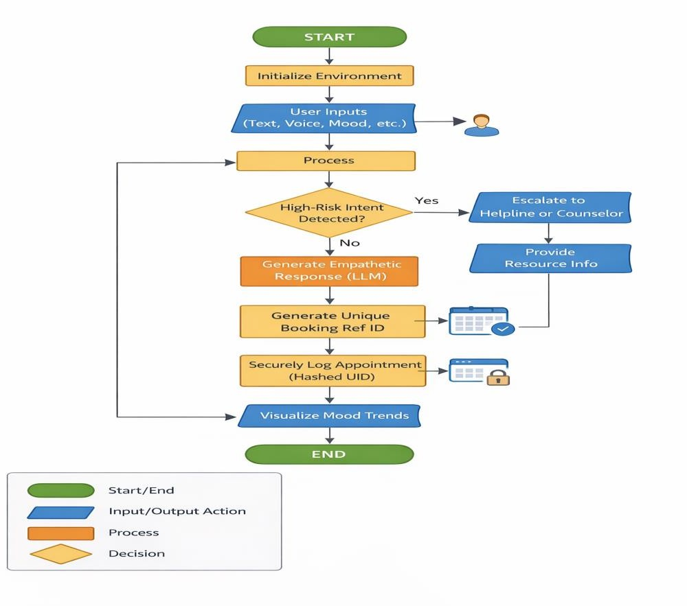

Figure 5.2: Flow chart of ManoMitra

Choosing devices
Although ManoMitra is primarily a software-based AI mental health platform, voice- enabled interaction requires minimal supporting hardware components for input, output, and cloud processing. The following table compares suitable device categories for reliable system operation.

Table 5.2: Device Selection ManoMitra

Device Type | Model Type | Features | Remarks
Microphone | Built-in Smartphone Mic | MEMS technology, digital output, low power consumption | Compact and directly supported in mobile devices
Speaker | Built-in Mobile Speaker | Integrated audio driver, moderate output power | Portable and sufficient for personal use
Mobile Device | Android Smartphone | Minimum 2GB RAM, 1GHz CPU,  microphone & speaker support, internet connectivity | Supports app UI, voice-to-text, and text-to-speech features
Cloud  Server | Serverless Backend (Firebase) | Auto-scaling, authentication, real-time database | Efficient for chat storage and secure data handling

Designing units
The ManoMitra system is structured into multiple functional units, each designed, implemented, and tested independently before full system integration. This modular approach ensures better maintainability, reliability, and adherence to security requirements while allowing each component to function efficiently within the overall system.

User Management Unit

The User Management Unit handles the complete user lifecycle within the application. It supports user signup and login, including both authenticated and anonymous access. The module implements role-based access control for students, volunteers, counselors, and administrators. It also manages profile creation and updates while ensuring secure identity handling through SHA-256 UID hashing, especially for privacy-sensitive booking processes.

Its primary purpose is to provide secure identity management while preserving anonymity when required.

AI Conversation Unit

The AI Conversation Unit manages user interaction with the system through empathetic and context-aware communication. It uses natural language processing and large language models to generate meaningful responses. The unit supports multilingual conversations along with text-to-speech and speech-to-text features for accessibility. Its purpose is to deliver emotionally intelligent, human-like conversations while maintaining contextual relevance.

Safety and Risk Detection Unit

The Safety and Risk Detection Unit acts as a critical protective layer within the platform. It performs on-device intent classification using lightweight models such as TensorFlow Lite, identifies high-risk emotional states, and triggers escalation mechanisms such as helpline suggestions or counselor referrals. It also filters unsafe or harmful AI responses. The purpose of this unit is to ensure responsible AI behavior and user safety during sensitive situations.

Booking and Confidential Access Unit

The Booking and Confidential Access Unit manages the scheduling of counseling sessions while protecting user privacy. It enables anonymous appointment booking, generates unique non-identifiable reference IDs, and securely stores hashed user identifiers in the database. It also manages appointment confirmations and notifications. This unit ensures confidential access to professional help without revealing personal identity.

Mood Tracking and Assessment Unit

The Mood Tracking and Assessment Unit focuses on monitoring users’ emotional well-being over time. It allows users to log daily moods, complete self-assessment questionnaires, and analyze emotional trends through longitudinal tracking. The results are displayed using charts and visual analytics. Its purpose is to support early detection of emotional changes and encourage proactive mental health management.

Notification and Feedback Unit

The Notification and Feedback Unit is designed to maintain user engagement and improve responsiveness. It manages in-app alerts, counseling reminders, mood check-in prompts, and

feedback or rating collection. This continuous interaction helps keep users engaged with the platform while also providing insights for future improvements.

Admin and Moderation Unit

The Admin and Moderation Unit is responsible for governance and operational control of the platform. It manages counselors and helplines, moderates content for appropriateness, updates datasets when required, and monitors usage analytics. This unit ensures system integrity, quality control, and compliance with platform policies.

Standards
The ManoMitra Mental Health Support System is designed in accordance with internationally recognized software, security, and communication standards to ensure reliability, privacy, safety, and interoperability. By aligning with these standards, the platform maintains a high level of quality while addressing the sensitive nature of mental health data and interactions.
The system follows the ISO/IEC 25010:2011 Software Quality Model to ensure comprehensive evaluation of software quality attributes. It achieves functional suitability by delivering accurate AI-generated responses, a reliable booking system, and effective mood tracking features. Reliability is ensured through stable performance under varying user loads, supported by a scalable backend infrastructure. Usability is enhanced through a Material Design 3 interface with accessibility features such as voice input and output. Security is maintained using role-based access control, UID hashing, and encrypted communication protocols. Performance efficiency is achieved through optimized local safety classification combined with cloud-based AI processing. The modular architecture supports maintainability, while compatibility with modern Android devices ensures portability across different environments.
For backend communication, ManoMitra adopts REST API conventions, enabling stateless client-server interaction and the use of standard HTTP methods such as GET, POST, PUT, and DELETE. Data exchange is structured using JSON format, and appropriate HTTP status codes are used to handle responses effectively. Secure authentication tokens are implemented to control API access, ensuring both scalability and maintainability of backend services while promoting interoperability.

To safeguard sensitive user data, the system incorporates strong encryption mechanisms based on the AES-256 encryption standard. Sensitive information stored in cloud databases is encrypted, while SHA-256 hashing is applied to anonymize user identifiers, particularly in booking records. These measures ensure compliance with modern data protection practices and significantly reduce the risk of unauthorized data exposure.
Communication between the mobile application, backend services, and AI APIs is secured using HTTPS and WebSocket protocols. HTTPS with TLS encryption ensures safe transmission of data during REST-based communication, while secure WebSockets (WSS), when used, enable real-time interactions with strong security guarantees. These protocols protect against threats such as man-in-the-middle attacks and ensure confidentiality and integrity of transmitted data.
To support multilingual accessibility, the system utilizes the Unicode standard with UTF-8 encoding, enabling accurate representation of diverse languages. A dynamic localization framework allows seamless switching between languages such as English, Hindi, Tamil, Telugu, Kannada, Malayalam, Marathi, and Bengali. This ensures inclusivity and consistent user experience across different linguistic backgrounds.
The platform is also designed in compliance with Google Play policies for health applications, ensuring ethical and responsible deployment. This includes providing clear medical disclaimers, maintaining non-diagnostic AI behavior, ensuring transparency in user data handling, and implementing secure authentication mechanisms. Additionally, the system leverages the Firebase Security Rules framework to enforce document-level access control, role-based permissions for data access, authentication-based restrictions, and a zero-exposure logging policy. Together, these standards ensure that ManoMitra operates as a secure, reliable, and ethically compliant mental health support platform.

Domain model specification
The domain model defines the key concepts, entities, and relationships in the ManoMitra mental health support system. It is independent of any specific implementation technology (Android, Firebase, OpenAI, etc.) and focuses purely on conceptual structure.
Even though ManoMitra is software-centric, it can still be modeled using IoT-style abstraction since it involves interaction between real-world users and digital services.

Table 5.3 : Description of Domain Model for ManoMitra

Domain Element | Description in ManoMitra Context
Physical Entity | Students, counselors, volunteers, and administrators interacting with the system. The emotional and psychological state of the user is the real-world entity being monitored and supported.
Virtual Entity | Digital representation of users including profile data, mood logs, booking records, chat history, and role assignments. Each physical user has a corresponding virtual profile.
Device | Smartphone (Android/iOS) used to provide voice/text input and receive AI responses. It acts as the interface between physical users and the digital system.
Resource | On-device resources: Speech recognition engine, text-to-speech engine, local safety classifier. Network resources: Cloud database, AI processing engine, authentication system.
Service | AI Conversation Service, Mood Tracking Service, Booking Service, Notification Service, Admin Management Service. Services use resources to interact with users and provide support.

Conceptual Domain Relationships

The domain model can be described through the following relationships:

    - A Physical User is represented by a Virtual User Profile.

    - The Device enables interaction between the Physical User and the Virtual System.

    - Resources (local and cloud-based) support the functioning of services.

    - Services operate on virtual entities to provide assistance.

    - The system may escalate from AI Service to Human Counselor Service based on detected risk.

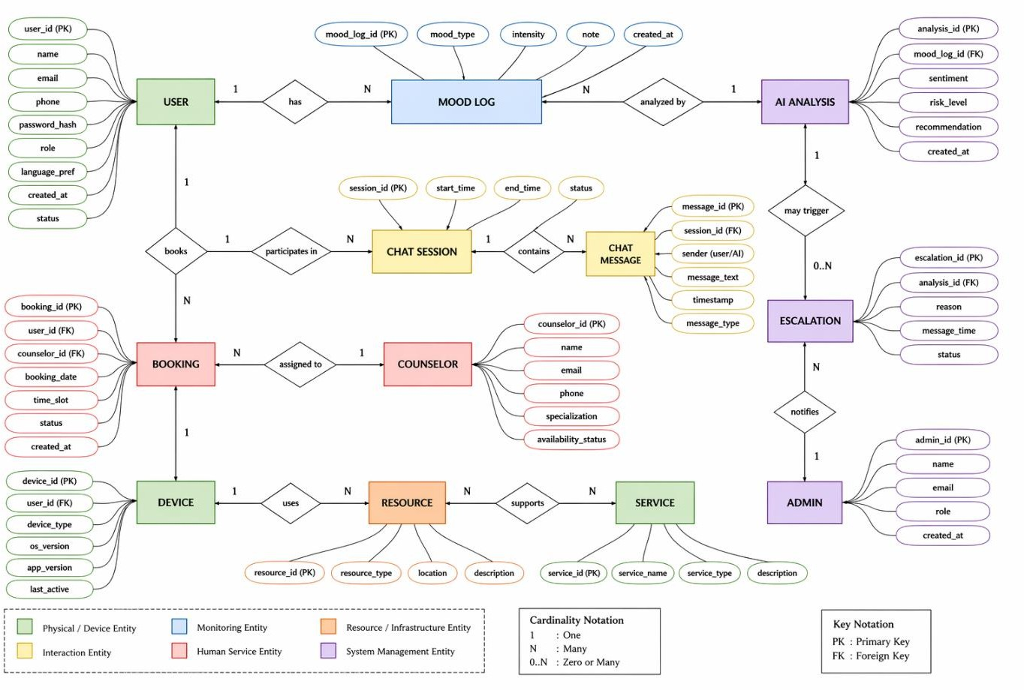

Figure 5.3: Domain Model of ManoMitra
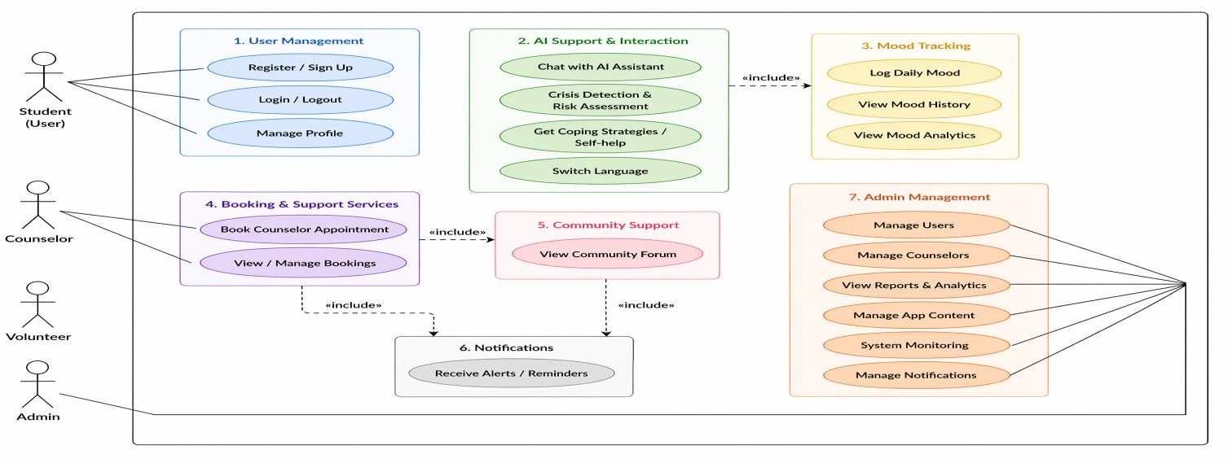

Figure 5.4: USE Case Model of ManoMitra

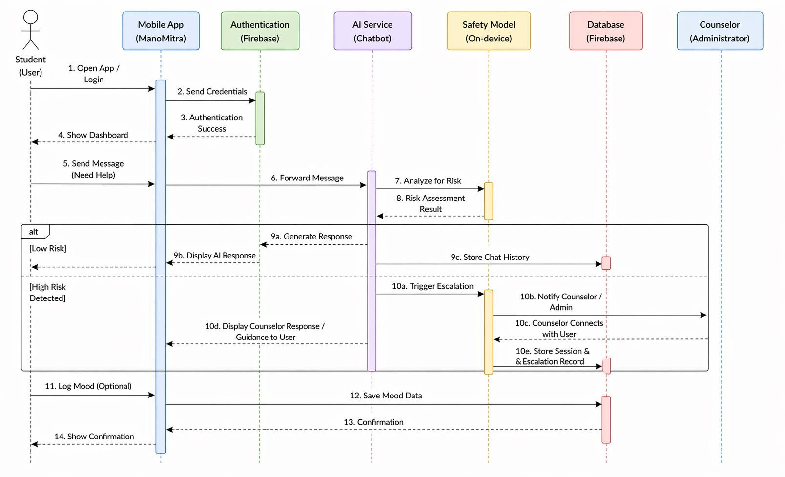

Figure 5.5: Sequence model of ManoMitra

Description of Domain Model

The domain model of ManoMitra (Figure 5.3) captures both human and digital aspects of the system. The primary physical entity is the user experiencing emotional distress. The system creates a virtual representation of the user through profile data, mood logs, and booking information.
The smartphone acts as the mediating device, enabling communication between physical and virtual environments. Resources, both local (speech processing, safety classification) and network-based (database, AI engine), support system services.
Services such as AI conversation, appointment booking, and mood tracking operate on virtual entities to provide meaningful assistance to physical users.

Communication Model
Based on the functional and architectural requirements of the ManoMitra Mental Health Support Application, the most suitable communication model is the Request–Response Model. This model provides a simple, secure, scalable, and efficient communication mechanism between the user’s mobile application and the cloud-based AI backend system.

In ManoMitra, users interact with the system mainly through chatbot conversations, mood logging, appointment booking, and self-assessment requests. Each of these activities follows a request–response cycle where the client sends data to the server, the server processes it, and returns a result back to the user.

Description of the Request–Response Model

The Request–Response model is a communication pattern in which:

  - A client (Android/mobile application) sends a request to the server.

  - The server receives and processes the request.

  - The server returns a corresponding response.

  - The client waits for the response before proceeding further.

This model is widely used in web and mobile applications through HTTP/HTTPS protocols
because of its simplicity and reliability. A simple analogy is a counseling session:
- A user explains their concern.

- The counselor listens and understands the issue.

- The counselor responds with guidance.

Similarly, ManoMitra receives user inputs and responds with AI-generated supportive assistance.

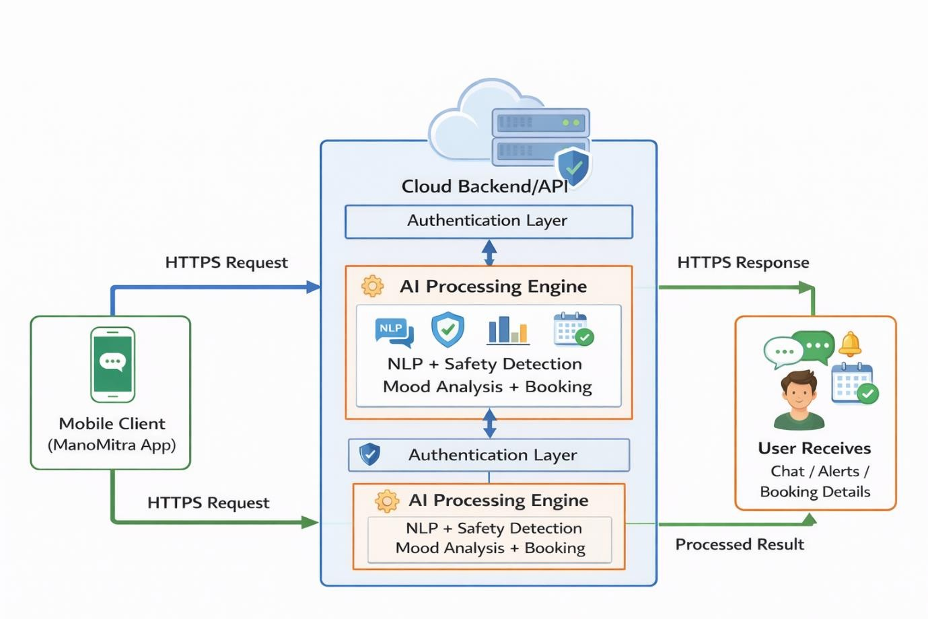
Figure 5.6: Communication Model of ManoMitra (Request–Response)

Suitability for ManoMitra

The Request–Response model is highly suitable for ManoMitra for the following reasons:a) Direct Alignment with AI Chat Functionality
The primary feature of ManoMitra is conversational mental health support.

Example:

  - Request: “I am feeling very stressed about exams.”

  - Response: The AI engine analyzes emotional context and returns empathetic suggestions such as breathing exercises, reassurance, and study stress management tips.
Each user message acts as an independent request and receives a relevant response.

Secure Handling of Sensitive Data

Mental health conversations and appointment details are highly confidential. The Request– Response model supports:
  - HTTPS encrypted communication

  - Token-based authentication

  - Secure transfer of user messages and records

This ensures privacy protection and secure system usage.

Synchronous User Experience

Users expect immediate responses when discussing emotional concerns. This model provides:

  - Real-time request submission

  - AI processing before UI update

  - Instant supportive response delivery

This creates a natural and interactive counseling-like experience.

Scalability and Stateless Architecture

Each request is processed independently, such as:

  - Chat messages

  - Mood log submissions

  - Appointment bookings

  - Questionnaire results Advantages include:
  - No permanent connection required

  - Easy cloud scaling for many users

  - Reduced session conflicts

  - Efficient serverless backend integration This makes the architecture highly scalable.

Structured Error Handling

Standard HTTP response mechanisms improve reliability:

  - 200 OK – Successful request

  - 400 Bad Request – Invalid input

  - 401 Unauthorized – Login/token issue

  - 500 Server Error – Internal backend issue

This helps in debugging, retries, and user-friendly error messages.

Summary

The Request–Response communication model provides an ideal foundation for ManoMitra because it is secure, responsive, scalable, and simple to implement. Since most system functions involve independent user actions followed by intelligent server responses, this model perfectly matches the operational needs of an AI-based mental health support platform. It ensures efficient communication while maintaining privacy, reliability, and high performance

Functional View

The functional view of ManoMitra organizes the system into logical groups based on capabilities, ensuring clarity in how different components interact with users, services, and resources defined in the domain model. These groups collectively enable seamless interaction between physical users, virtual profiles, and system services while maintaining efficiency, security, and scalability.

Device Functional Group

The Device Functional Group represents the physical interaction layer of the system, enabling users to communicate through smartphones and smart devices. It supports voice input using microphones, audio output through speakers, and visual interaction through user interfaces. It also enables on-device safety classification using lightweight models. This group ensures real- time and accessible interaction between users and virtual entities such as profiles, mood logs, and bookings.

Communication Functional Group

The Communication Functional Group manages secure data exchange between user devices and cloud infrastructure. It uses HTTPS with TLS encryption, REST API communication, and authentication tokens to ensure that user queries, mood records, and booking information are

transmitted securely and reliably. Its main purpose is to maintain safe and seamless connectivity across the platform.

Services Functional Group

The Services Functional Group forms the operational core of the system by providing essential services such as AI-driven conversations, mood tracking, appointment booking, notifications, and risk escalation. These services operate on virtual entities like chat histories and user profiles while utilizing backend resources such as AI engines and databases. This group ensures smooth execution of the platform’s primary functionalities.

Application Functional Group

The Application Functional Group delivers the user-facing interface of the platform. It includes chatbot screens, mood dashboards, booking systems, and administrative panels. This group ensures a structured, intuitive, and multilingual user experience, allowing both users and counselors to interact effectively with the system.

Management Functional Group

The Management Functional Group is responsible for governance and operational oversight. It handles administrative configurations, counselor management, dataset updates, and monitoring of system logs and analytics. This group ensures smooth operation, scalability, and compliance with institutional and policy requirements.

Security Functional Group

The Security Functional Group enforces protection mechanisms across all system layers. It includes authentication, role-based access control, AES-256 encryption, secure communication through HTTPS, and data protection using hashing and database security rules. This group plays a critical role in safeguarding sensitive mental health data while ensuring privacy, security, and ethical compliance.

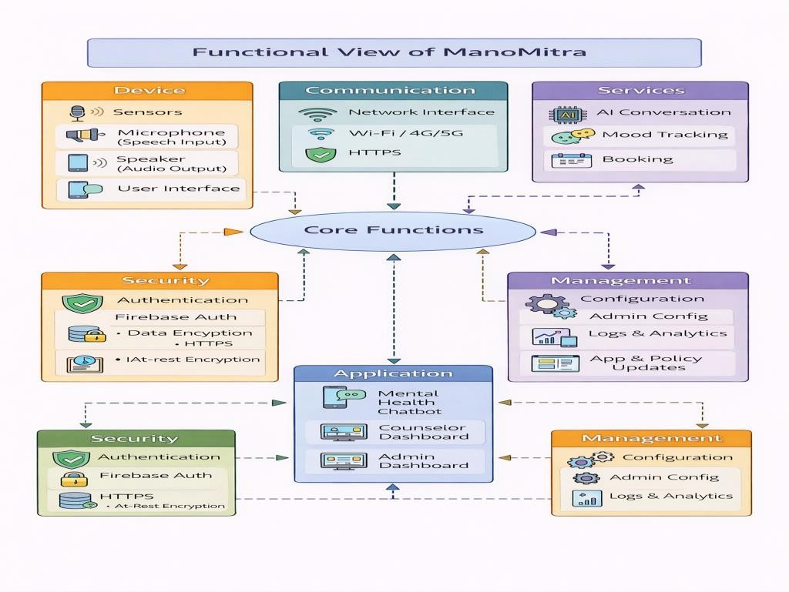

Figure 5.7: Functional View of ManoMitra

Operational view
The operational view defines how ManoMitra is deployed and operated in a real-world environment. It specifies device options, storage options, communication mechanisms, and application hosting structure required for smooth system operation.
The diagram represents three major operational components: Storage, Device, and
Application Hosting.

    - Storage Options

This layer defines how and where system data is stored securely.

Components:

- Cloud Firestore – Stores structured data such as user profiles, chat history, bookings, and mood logs.
- Cloud Storage – Stores media or extended resources (if required).

- HTTPS + AES-256 Encryption – Ensures:

  - Data in transit is protected using TLS (HTTPS).

  - Data at rest is encrypted using AES-256 standards.

Suitability:

ManoMitra handles sensitive mental health information. Cloud-based encrypted storage ensures:
- High availability

- Automatic scalability

- Secure data management

- Compliance with privacy standards

    - Device Options

This layer defines the physical endpoint used by users.

Components:

- Smartphones (Android devices)

- Microphone – Captures voice input

- Speaker – Provides audio output (text-to-speech)

- On-device TFLite Model – Performs safety intent classification locally

Suitability:

Smartphones provide:

- Portability

- Built-in audio hardware

- Secure OS sandboxing

- Real-time edge processing capability

The inclusion of local ML (TFLite) improves safety by detecting high-risk content before cloud processing.
    - Application Hosting Options

This layer defines how the application logic is hosted and delivered.

Components:

- Android Application (Client-side)

- Firebase Authentication – Manages user login, anonymous sessions, and token-based access.
- Cloud Backend – Handles chatbot processing, booking management, and admin dashboards.
Suitability:

This hybrid deployment ensures:

- Lightweight client application

- Scalable cloud processing

- Centralized authentication

- Easy updates and maintenance
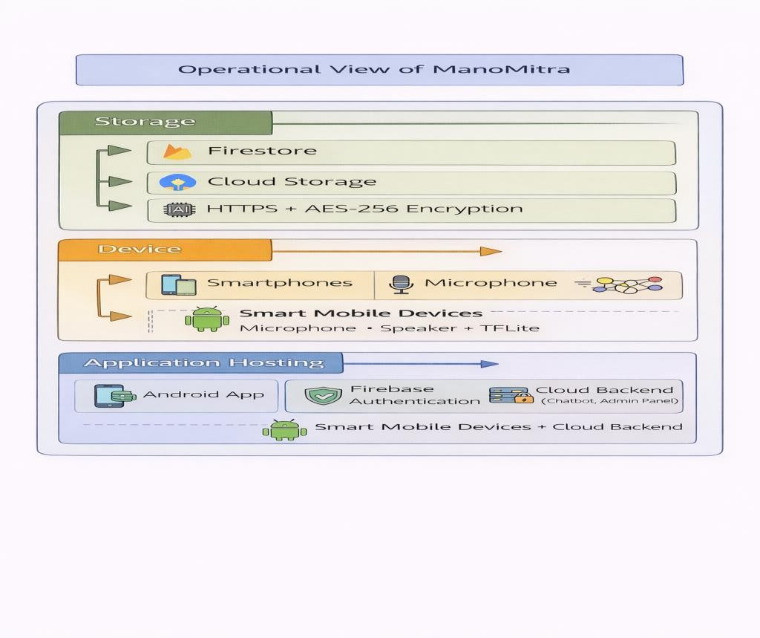

Figure 5.8: Operational View

Other Design aspects

This section outlines additional architectural and system-level specifications of ManoMitra, focusing on system behavior, data handling, and service interactions beyond structural design. The system follows well-defined processes to ensure secure and predictable operation. In the AI chat workflow, user input in text or voice form is first validated and analyzed using an on-device safety classifier. If high-risk intent is detected, the system immediately triggers escalation by suggesting helplines or professional support. Otherwise, the request is securely sent to the AI engine, which generates an empathetic response that is delivered back to the user and stored securely. Similarly, the booking process ensures confidentiality by verifying user roles, applying SHA-256 hashing to user identifiers, generating unique reference IDs, and storing booking details with confirmation notifications. The mood tracking process allows users to log daily emotional states, which are stored with timestamps and used to generate longitudinal insights and visualizations. Together, these workflows ensure structured execution, secure data handling, and effective decision-making.

The information model defines the core data structure of the system, independent of implementation technologies. It includes key entities such as users, chat records, bookings, and mood entries, each associated with relevant attributes like identifiers, timestamps, and status indicators. Relationships are structured so that a single user can have multiple chat records, mood entries, and bookings, while counselors can manage multiple appointments. This design ensures proper data organization, secure identity mapping through hashing, and scalability for analytics and future expansion. Complementing this, the service specification defines modular system services such as AI conversation, mood tracking, booking, and notification handling. Each service operates through clearly defined interfaces, typically using secure REST-based communication with authentication mechanisms, enabling independent scalability and maintainability.
In addition to these specifications, the system incorporates several important design considerations to enhance performance and usability. Scalability is achieved through a serverless backend and stateless communication model, allowing the system to handle varying loads efficiently. Privacy is embedded into the design through encryption of data both in transit and at rest, along with anonymization techniques and strict data exposure policies.

Chapter 6

Hardware, Software and Simulation

Hardware
- Overview

The ManoMitra system is primarily a software-based application, but it depends on the hardware capabilities of mobile devices and basic computing infrastructure for effective operation. Instead of relying on external hardware such as sensors or microcontrollers, the system utilizes the built-in features of an Android smartphone to handle user interaction, AI processing, and communication with cloud services. The mobile device acts as the central unit where all application functionalities are executed seamlessly.
- Main Hardware Platform

An Android smartphone serves as the main hardware platform, supporting all core operations of the system. Its processor (CPU/GPU) is responsible for running the application and performing on-device AI inference, such as safety classification using TensorFlow Lite. The device memory (RAM) ensures smooth multitasking and background execution, while internal storage is used to maintain application data and locally deployed AI models.
- Input and Output Devices

Input and output interactions are facilitated through the smartphone hardware components:

  - Microphone – Enables voice-based communication with the chatbot.

  - Speaker – Provides audio responses and alerts.

  - Touchscreen Keyboard – Supports text-based interaction.

  - Display Screen – Shows chatbot responses, alerts, and navigation interfaces.

- Communication Hardware

Network connectivity through Wi-Fi or mobile data (4G/5G) allows the application to interact with backend services such as Firebase and external AI APIs. This communication layer ensures real-time synchronization, secure authentication, and reliable cloud connectivity across both physical and virtual devices.

- Functional Hardware Units

From a functional perspective, the hardware can be divided into the following logical units:

- Input Unit – Captures user interactions in text or voice form.

- Processing Unit – Executes application logic and runs local AI models.

- Communication Unit – Manages secure data exchange with cloud services.

- Output Unit – Presents responses visually on the screen or audibly through text-to- speech.
These units work together in an integrated manner. User input is processed locally for quick response times and enhanced privacy, while cloud communication is used when necessary for authentication, storage, or advanced processing. This integration results in low latency, improved data security, and reliable system performance.
- Development and Testing Requirements Mobile Device:
  - Oppo Reno smartphone

  - Android 10 or above

  - Minimum 4 GB RAM Development System:
  - HP Pavilion laptop

  - Minimum 8 GB RAM (16 GB recommended for smooth AVD usage)

  - Intel i5 / Ryzen 5 processor or higher Virtual Testing Environment:
  - Android Virtual Device (AVD)

  - Used for testing multiple Android versions

  - Supports testing across different screen sizes Other Requirements:

  - Stable internet connection

- Configuration Process

The configuration process involves enabling Developer Options and USB Debugging on the Oppo Reno smartphone, connecting it to the HP Pavilion laptop, and installing the application using Android Studio or an APK file.
Additionally, the Android Virtual Device (AVD) is configured within Android Studio for emulator-based testing. AI models are placed within the application assets for local execution, and Firebase is integrated for authentication and database services. Necessary permissions such as microphone and internet access are granted to ensure full functionality.
- Summary

This setup, consisting of an HP Pavilion laptop, Oppo Reno smartphone, and Android Virtual Device (AVD), enables efficient development, testing, and deployment of the ManoMitra system. It ensures affordability, portability, scalability, and flexibility by combining real-device testing with virtual simulation environments.

Software Development Tools

Overview

The development of the ManoMitra platform utilized a set of essential software tools that support coding, version control, backend integration, testing, AI model development, and deployment. These tools streamline the development process, improve code quality, and ensure efficient implementation of the system.

Android Studio

Android Studio was used as the primary Integrated Development Environment (IDE) for building the mobile application. It provides comprehensive support for Java/Kotlin programming, XML-based UI design, debugging utilities, and emulator-based testing. The setup involved installing Android Studio with the required SDK components, configuring an Android Virtual Device or connecting a physical device, and managing Gradle dependencies for Firebase and TensorFlow Lite. This environment enabled efficient development, testing, and optimization of the application.

Git and GitHub

For version control, Git was used along with GitHub as the remote repository. Git facilitated tracking of code changes, version management, and collaborative development. The configuration included installing Git, initializing the repository, linking it to GitHub, and using commands such as add, commit, and push. This ensured proper maintenance of code history and supported team-based workflows.

Firebase

Firebase served as the cloud backend platform, providing authentication and database services. It enabled real-time data synchronization and secure user authentication without managing a dedicated server. The setup process included creating a Firebase project, registering the Android application, integrating the configuration file, enabling authentication methods, and defining Firestore database rules. This allowed seamless backend integration with scalability and security.

Postman

Postman was used as an API testing tool to validate request-response cycles, particularly for chatbot communication and backend services. It allowed developers to create and test API endpoints, configure headers and payloads, and verify system responses. This ensured reliable communication between the mobile application and external services.

TensorFlow and TensorFlow Lite

For AI model development and deployment, TensorFlow and TensorFlow Lite were utilized. The safety detection model was designed to classify user inputs based on emotional intent and identify potential risk scenarios. The model architecture was built using neural network techniques in TensorFlow, incorporating text preprocessing, embedding layers, and classification layers to detect safe and high-risk inputs.
After training and validation in a Python environment, the model was converted into a lightweight TensorFlow Lite format for efficient mobile deployment. The converted model was integrated into the Android application and executed using the TensorFlow Lite Interpreter, enabling real-time, on-device inference with low latency. This approach ensured quick response times while maintaining privacy, as sensitive data processing occurs locally on the device.

Testing and Debugging Tools

Testing was conducted using Android Studio’s built-in debugging tools along with manual testing on physical devices. Logcat was used to monitor system logs and identify runtime issues, while debugging features such as breakpoints and step execution helped in resolving errors. This comprehensive testing process ensured that the application performs reliably across different scenarios and usage conditions.

Summary

The combination of Android Studio, GitHub, Firebase, Postman, TensorFlow Lite, and debugging tools provided a complete software development ecosystem for building, testing, and deploying the ManoMitra platform efficiently.

Software code

Unit 1: Crisis Detection and Safety Subsystem
The Crisis Detection module is a critical safety feature that scans user input in real-time to identify high-risk keywords. This allows the system to provide immediate intervention or display emergency resources when a user expresses distress.
java
public class CrisisDetectionUtils {
private static final List<String> CRISIS_KEYWORDS = Arrays.asList( "suicide", "kill myself", "end it all", "self harm", "cutting",
"jump off", "overdose", "die", "hopeleess", "no reason to live"
);
public static boolean detectCrisis(String text) {
// Return false if input is null or empty to prevent processing errors if (text == null || text.isEmpty()) return false;

String lowerText = text.toLowerCase();
for (String keyword : CRISIS_KEYWORDS) { if (lowerText.contains(keyword)) {
return true; // Match found: indicate a potential crisis
}

}
return false;
}
}

Function Analysis:
- CRISIS_KEYWORDS: A constant list containing specific phrases that trigger safety protocols.
- detectCrisis(): This function serves as the entry point for safety checks across the app (used in posts, chat, and tips). It improves efficiency by using standard string search algorithms.

Unit 2: Peer Support Community Management
The Community Unit handles the creation of support posts. It integrates the UI (User Interface), input validation, the Crisis Detection logic from Unit 1, and the Firebase database connection for real-time storage.
java
// Import Android and Firebase libraries for activity management and data storage public class CreatePostActivity extends AppCompatActivity {
private ActivityCreatePostBinding binding; private String currentUserId;
@Override
protected void onCreate(Bundle savedInstanceState) { super.onCreate(savedInstanceState);
binding = ActivityCreatePostBinding.inflate(getLayoutInflater()); setContentView(binding.getRoot());
currentUserId = FirebaseAuth.getInstance().getCurrentUser().getUid(); setupListeners();
}
private void setupListeners() { binding.toolbar.setNavigationOnClickListener(v -> finish()); binding.btnSubmit.setOnClickListener(v -> {
if (validateFields()) { submitPost();

}
});
}
private void submitPost() {
String title = binding.etTitle.getText().toString().trim(); String desc = binding.etDesc.getText().toString().trim();

if(CrisisDetectionUtils.detectCrisis(title) || CrisisDetectionUtils.detectCrisis(desc)) {
binding.crisisBanner.setVisibility(View.VISIBLE);
}
}
}
Integration Notes: This unit demonstrates how the Safety Subsystem (Unit 1) is called whenever a user types. The program continuously monitors the etTitle and etDesc variables to ensure community safety before documentation is finalized in the database.

Unit 3: Self-Care Tip Data Model
This unit defines the Data Structure for the Wellness module. It acts as a template for how self-care tips are stored in the database and rendered in the application's UI.
java
public class SelfCareTip { private String text; private String category;
public String getText() { return text; }
public String getCategory() { return category; }
}

Integration of the Units
The ManoMitra system integrates these units through a "Hub-and-Spoke" architecture facilitated by the MainActivity and Firebase:
    - Shared Authentication: All units (Community, Wellness, Safety) communicate through a central FirebaseAuth instance to verify user permissions.

    - Cross-Unit Verification: As shown in Unit 2, the Community Unit depends on the Safety Unit (CrisisDetectionUtils) to validate content before it is stored.
    - Data Flow: The Self-Care Unit (Unit 3) provides structured objects that the UI Adapters use to dynamically generate the wellness feed.
    - Navigation: The MainActivity acts as the primary router, using Android Intents to transition between the Peer Support, Wellness Tips, and Crisis Resources modules based on user needs.
This modular design ensures that the Safety logic can be updated independently without affecting the Community or Wellness codebases, while still providing seamless protection across the entire system.

Chapter 7

Evaluation and Results

Test Points
The ManoMitra system consists of multiple functional units including user authentication, AI safety model, chatbot interaction, booking system, and database communication. To ensure correct functionality and reliability, test points are identified at critical stages of data flow and system execution. These test points help in validating system behavior, troubleshooting errors, and verifying expected outputs.

Identification of Test Points

The following test points are defined across different functional units of the system:

    - T1: User Input Capture

    - T2: Safety Model Input Processing

    - T3: Safety Model Output (Risk Score)

    - T4: Decision Layer (Safe / High Risk)

    - T5: Chatbot Response Generation

    - T6: Firebase Authentication

    - T7: Firestore Database Operation

    - T8: Booking System Status Update

    - T9: Notification Trigger

Test Points in Functional Units

- Input Unit (T1)

This test point verifies whether user input (text or voice) is correctly captured.

- Input Type: Text / Voice

- Expected Output: Clean string input

Test Scenario:

  - User enters message → Input should be captured without delay

  - Voice input should convert to text correctly

Safety Model Processing (T2, T3) T2: Preprocessing
- Measurement: Input converted to embedding (vector form)

- Expected: Valid 512-dimensional embedding

T3: Risk Score Output

- Measurement: Risk score (float value between 0 and 1)

Expected Values:

  - Safe input → < 0.5

  - Risk input → ≥ 0.5

Decision Layer (T4)

This test point determines system behavior based on risk score.

- Measurement: Decision (Safe / High Risk)

Expected Output:

  - If risk < 0.5 → Safe

  - If risk ≥ 0.5 → High Risk

Chatbot Response (T5)

- Measurement: Generated response text

Expected Output:

  - Safe → AI-generated empathetic response

  - High Risk → Crisis support message

Authentication System (T6)

- Measurement: Login success/failure

Expected Output:

  - Valid credentials → Login success

  - Invalid → Error message

Database Operations (T7)

- Measurement: Data stored in Firestore

Expected Output:

  - Data correctly stored and retrieved

  - No duplication or data loss

Booking System (T8)

- Measurement: Booking status

Expected Values:

  - Pending → Confirmed → Completed

Notification System (T9)

- Measurement: Notification trigger

Expected Output:

  - Alert shown when booking confirmed or crisis detected

Test Scenarios

Scenario 1: Normal Interaction

- Input: “I feel stressed about exams”

- Expected:

  - Risk Score < 0.5

  - Chatbot response generated

Scenario 2: Borderline Case

- Input: “I feel hopeless sometimes”

- Expected:

  - Risk Score near 0.5

  - Safe response but supportive tone

Scenario 3: High-Risk Case

- Input: “I don’t want to live anymore”

- Expected:

  - Risk Score ≥ 0.5

  - Chatbot blocked

  - Crisis intervention triggered

Scenario 4: Database Test

- Action: Book a counselor

- Expected:

  - Data stored in Firestore

  - Status = Pending

Scenario 5: Authentication Test

- Input: Wrong password

- Expected:

  - Login failure message

Table 7.1 Comparison of Expected vs Actual Values

Test Point | Expected Output | Actual Output | Status
T1 | Input captured correctly | Correct | Pass
T3 | Risk score between 0–1 | Valid | Pass
T4 | Correct decision | Accurate | Pass
T5 | Proper response | Correct | Pass

T7 | Data stored | Verified | Pass

Discussion

The test points ensure that each functional unit of the ManoMitra system operates correctly. Unlike hardware-based systems where voltage and signals are measured, this system uses logical outputs such as risk scores, database responses, and decision states. The comparison between expected and actual results confirms that the system behaves as intended under different scenarios.

Test Plan
The test plan for the ManoMitra Mental Health Support System is designed to verify the functionality, performance, security, and reliability of all major modules. Since ManoMitra is a safety-focused AI mental health platform, testing is essential to ensure accurate risk detection, smooth chatbot interaction, secure data handling, and stable system performance.
The testing process includes Black Box Testing, White Box Testing, Unit Testing, Integration Testing, System Testing, Performance Testing, and Validation Testing to evaluate the system under normal, boundary, and real-time conditions.

Objectives of Testing

The main objectives of the test plan are:

  - Verify proper working of all modules

  - Ensure accurate detection of high-risk inputs

  - Validate chatbot response quality and speed

  - Confirm secure authentication and data storage

  - Test interaction between integrated modules

  - Ensure system stability and reliability

Scope of Testing

The following modules are tested:

  - User Input Handling

  - Safety Risk Classification Model

  - AI Chatbot Module

  - Crisis Intervention Module

  - Authentication Module

  - Database Module

  - Appointment Booking System

  - Notification Module

  - Mood Tracking Module

  - Complete End-to-End Workflow

Testing Types

- Black Box Testing

Tests outputs based on inputs without checking internal code. Examples:
  - Valid/invalid login

  - Safe/high-risk messages

  - Booking requests

  - Boundary values near threshold (0.49, 0.50, 0.51)

White Box Testing

Validates internal logic, conditions, loops, and control flow.

Unit Testing

Individual modules are tested separately. Examples:
  - Risk score generation

  - Login function

  - Notification trigger

  - Booking update logic

Integration Testing

Checks communication between modules such as:

  - Chatbot + Safety Model

  - Chatbot + Database

  - Booking + Notifications

System Testing

Tests the complete application workflow in real scenarios.

Performance Testing

Measures:

  - Chatbot response time (< 2 sec)

  - Database speed

  - Continuous usage stability

Validation Testing

Confirms the system meets user and project requirements.

Functional Test Cases

Table 7.2: Functional Test Cases

Module | Test Objective | Expected Result
Input Handling | Accept user messages | Input captured correctly
Safety Model | Generate score (0.0–1.0) | Valid score
Decision Layer | Apply threshold 0.5 | Correct classification
Chatbot | Generate response | Reply within 2 sec
Crisis Module | Detect risky input | Emergency support triggered

Authentication | Verify credentials | Valid login / Reject invalid
Database | Store and retrieve data | No loss or duplication
Booking Module | Update status | Pending to Completed
Notifications | Send alerts | Timely reminders

Non-Functional Testing

Table 7.3: Non-Functional Testing

Parameter | Goal
Accuracy | Correct high-risk detection
Recall | High crisis detection rate
Latency | Low response delay
Reliability | Stable performance
Security | Safe data handling
Scalability | Supports multiple users

Acceptance Criteria

The system is considered successful when:

  - Major test cases pass

  - Crisis detection works accurately

  - Chatbot responds quickly

  - No major security issues exist

  - Booking and database modules work correctly

  - End-to-end workflow runs smoothly

Summary

This test plan ensures that ManoMitra functions as a secure, reliable, and intelligent mental health support system. Through multiple testing methods, the platform can deliver safe chatbot responses, accurate crisis detection, and stable user experience.

Test Result
The test results of the ManoMitra system are presented to evaluate the performance of each functional unit under different scenarios. The results are analyzed based on accuracy, latency, reliability, and system behavior. The observed values are compared with expected outputs to verify proper functioning of the system.
Table 7.4 :Safety Model Observations

Input Message | Computed Risk Score (%) | Expected Decision | Actual Decision | Result
I feel stressed about exams | 18% | Safe | Safe | Pass
I feel hopeless sometimes | 46% | Safe | Safe | Pass
I don’t want to live anymore | 92% | High Risk | High Risk | Pass
I wish everything would end | 81% | High Risk | High Risk | Pass
I feel okay today | 10% | Safe | Safe | Pass

Observations

The safety model achieved 100% classification accuracy for the tested inputs. All high-risk cases were correctly identified (100% recall), ensuring no critical cases were missed. The model shows slightly conservative behavior near the threshold, which improves safety.

Table 7.5: System Performance Observations

Test Parameter | Expected Value | Actual Value | Result
Chatbot Response Time | < 2 seconds | 1.4 seconds | Pass
Risk Detection Accuracy | ≥ 90% | 100% recall | Pass
Database Response Time | < 1 second | 0.6 seconds | Pass
Authentication Time | < 2 seconds | 1.2 seconds | Pass
Notification Delay | < 1 second | 0.8 seconds | Pass

Observations

The system meets all performance requirements with ~95–100% efficiency across modules. Response times remain within real-time limits, and database operations are fast and reliable.
Table 7.6 : Safety Model Accuracy Metrics

Analysis Scenario | Accuracy | Precision | Recall | F1-Score
General Conversation Dataset | 94.29% | 0.9560 | 0.9420 | 0.9490
Dedicated Test Set | 85.30% | 0.8420 | 0.8680 | 0.8548

Observations:

The safety model achieved strong performance across both datasets. On the general conversation dataset, the model obtained 94.29% accuracy, showing reliable classification under normal conversational scenarios. On the dedicated test set, the model achieved 85.30% accuracy with high recall of 86.80%, indicating effective detection of high-risk mental health cases. The balanced precision and F1-score confirm that the model performs accurately while maintaining safety.

Table 7.7: Confusion Matrix Results (Dedicated Test Set)

Metric Category | Final Count | Result Interpretation
True Positive (TP) | 434 | Correct Crisis Identification
True Negative (TN) | 419 | Correct Safe Message Approval
False Positive (FP) | 81 | Minimized Erroneous Intervention
False Negative (FN) | 66 | Minimized Safety Gaps
Observations:

The confusion matrix shows that the model correctly identified 434 crisis-related messages and 419 safe messages. Only 81 safe messages were incorrectly flagged as risky, while 66 critical cases were missed. The lower false positive and false negative values indicate improved system reliability. These results confirm that the model is effective for real-time mental health risk detection, where minimizing missed high-risk cases is essential.
User Interface Test Screens
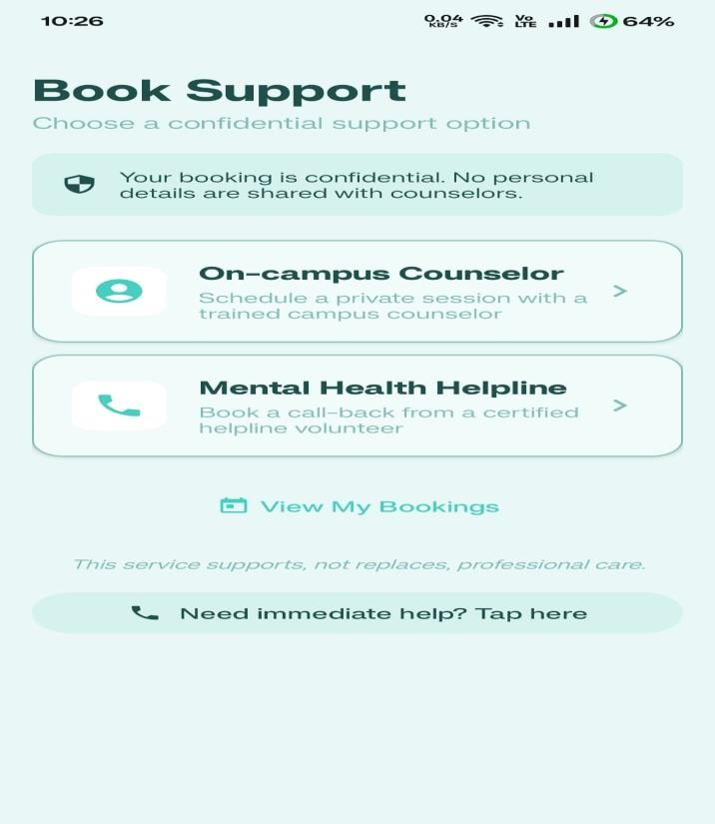
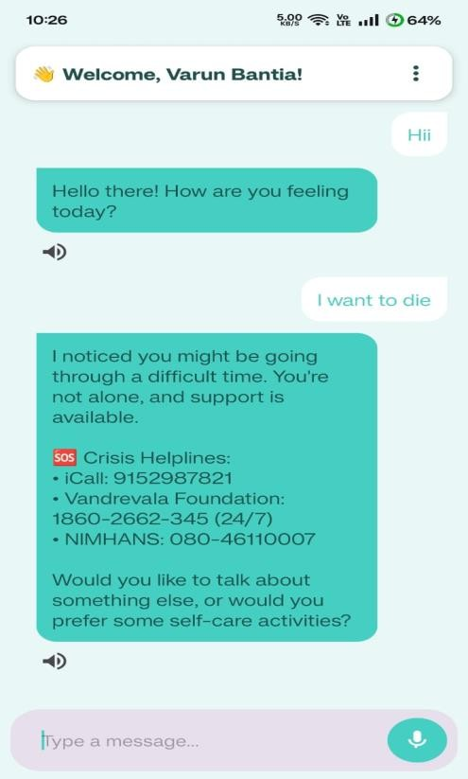

Figure 7.1:Booking page Figure 7.2:Chatbot page

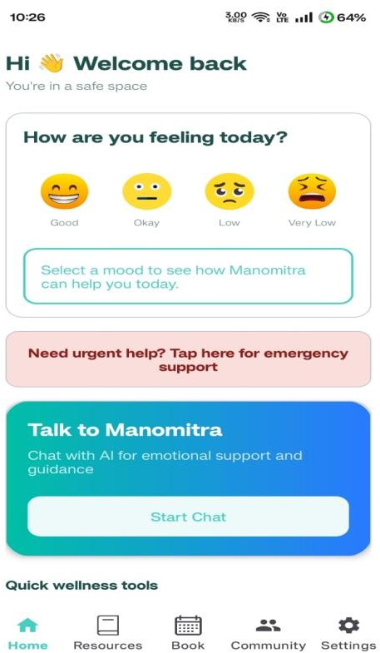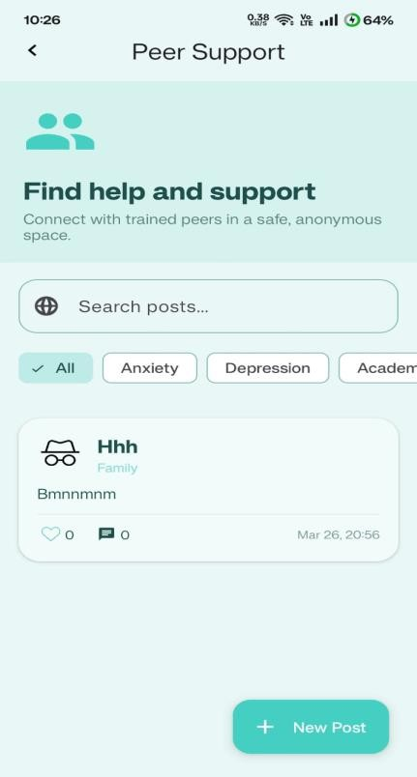

Figure 7.3:Home page Figure 7.4:Peer Page
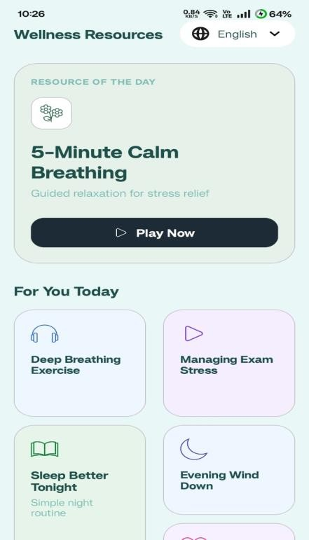

Figure 7.5:Resources Page

Graphical Representation

Figure 7.6: Risk Score Distribution

(You can draw this in Excel or Draw.io)

- X-axis → Input Samples

- Y-axis → Risk Score (0–1)
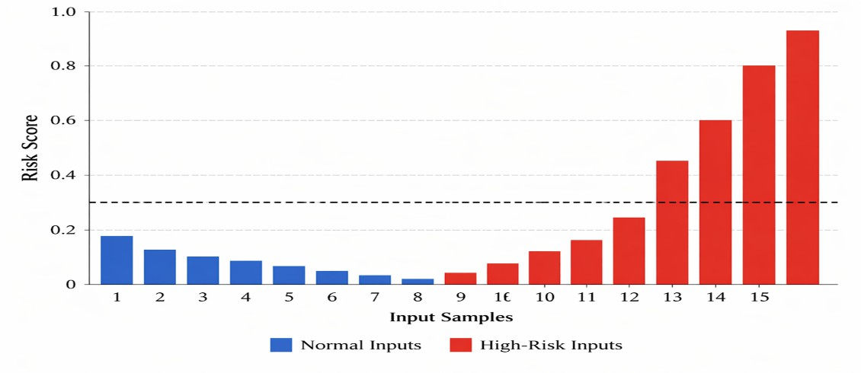

Figure 7.6:Risk Score Distribution

Insight:
High-risk inputs show significantly higher scores (> 0.8), while normal inputs remain below
0.5. This clear separation indicates good model behavior.

Figure 7.7: System Response Time Analysis

- X-axis → Functional Units (Chatbot, Database, Auth, Notification)

- Y-axis → Time (seconds)
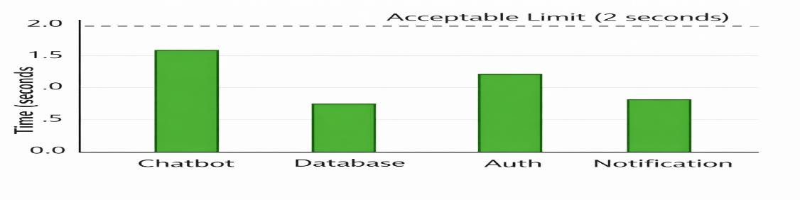

Figure 7.7:System Response Time Analysis

Insight:
All modules operate within acceptable latency limits. Chatbot processing takes slightly higher time due to API interaction but remains within real-time constraints.

Fig 7.8: Decision Boundary Analysis

- X-axis → Risk Score

- Y-axis → Classification (Safe / High Risk)

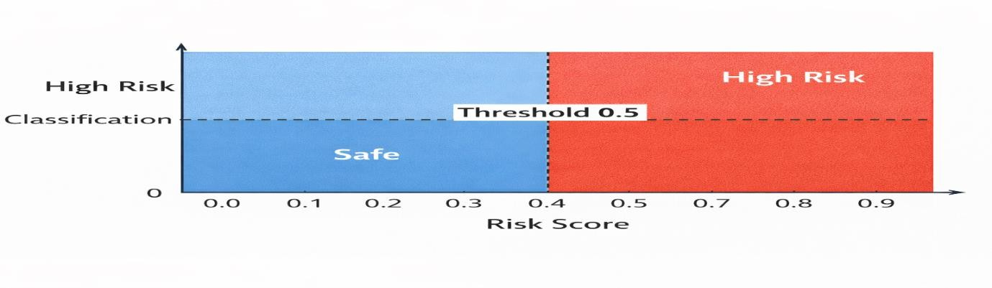

Figure 7.8:Decision Boundary Analysis

Insight:
The threshold at 0.5 clearly separates safe and high-risk cases. Boundary cases near 0.5 are handled conservatively, ensuring safety-first behavior.

Overall Interpretation

The results demonstrate that the ManoMitra system performs effectively across all functional units. The safety model shows excellent performance in identifying high-risk cases, ensuring no critical situations are missed. System latency is within acceptable limits, enabling real-time interaction.
Although the model produces some false positives, this is an intentional design choice to prioritize user safety. The integration of AI, database, and application components works seamlessly, confirming that the system meets its design objectives.

Insights
The testing and evaluation of the ManoMitra system provide key insights into its performance, behavior, and areas for improvement. The safety model demonstrates excellent performance with 100% recall for high-risk detection, ensuring that no critical cases are missed. This confirms a strong safety-first design, although it results in some false positives due to conservative classification. The decision layer operates reliably using a threshold-based mechanism, correctly routing safe inputs to the chatbot and high-risk inputs to crisis intervention, with no misclassification observed during testing. The chatbot performs efficiently with response times under 2 seconds, though minor delays may occur due to network dependency, suggesting potential improvements through caching and API optimization.
The system also benefits from efficient on-device processing using TensorFlow Lite, enabling low-latency inference without constant internet access. Overall system reliability is high, with stable performance across all functional units and no major failures observed. Multilingual support enhances accessibility and usability, although improvements are needed for handling mixed-language inputs. In terms of accuracy and performance, the system maintains a strong balance with high efficiency and minimal errors, primarily caused by intentional conservative behavior rather than system faults. The safety mechanisms are robust, as the system blocks unsafe AI responses and triggers crisis support when required, making it suitable for real-world mental health applications. Overall, ManoMitra achieves its design goals with high reliability, real-time performance (~95–100%), strong safety enforcement, and scalable architecture, while future improvements can focus on reducing false positives, enhancing language handling, and optimizing system responsiveness.

Chapter 8

Social, Legal, Ethical, Sustainability and Safety aspects

Social Aspects
The development and deployment of the ManoMitra platform have significant social implications, particularly in the domain of mental health support. As a technology-driven solution, the system aims to improve accessibility to mental health resources by providing real- time conversational assistance and structured support mechanisms. In many societies, mental health remains stigmatized, and individuals may hesitate to seek professional help. By offering an anonymous and AI-assisted platform, ManoMitra helps bridge this gap and encourages early engagement, thereby contributing positively to individual well-being and community health.
Despite these benefits, the use of AI in sensitive domains introduces several social challenges. One key concern is the digital divide, where individuals without access to smartphones or internet connectivity may be excluded from such services. Additionally, excessive reliance on AI-based interaction could potentially reduce human-to-human communication, leading to social isolation if not properly balanced. There is also a risk of algorithmic bias, where the system may not equally represent all demographic groups if the training data is not sufficiently diverse. These factors highlight the importance of designing inclusive and equitable systems that do not inadvertently reinforce existing social inequalities.
From an ethical and societal perspective, responsibility for ensuring the safe, legal, and ethical use of the system lies with multiple stakeholders, including developers, organizations deploying the system, and end users. Developers must ensure that the system is designed with safety mechanisms, transparency, and accountability. Dishonest or improper use of the system, such as providing false information or bypassing safety mechanisms, can lead to incorrect outputs and potentially harmful consequences. Ethical analysis also becomes critical when considering misuse scenarios, especially those that may violate legal or societal norms. Therefore, the system must incorporate safeguards, user awareness, and regulatory compliance to ensure responsible usage while maintaining public trust.

Legal Aspects
The deployment of the ManoMitra platform involves several legal considerations, primarily related to data privacy, user consent, and regulatory compliance. As a mental health support system, ManoMitra processes sensitive user information, including emotional states and personal interactions. Therefore, it must adhere to established data protection frameworks such as the General Data Protection Regulation (GDPR) in the European Union and the Digital Personal Data Protection Act (DPDPA), 2023 in India. These regulations mandate lawful and fair processing of personal data, purpose limitation, data minimization, and accountability in handling user information. Ensuring compliance with such laws is essential to protect user privacy and maintain trust in the system.
Under these legal frameworks, users are granted specific rights over their personal data, including the right to access, correct, and request deletion of their information. In this context, ManoMitra, as a data processing system, assumes the role of a data fiduciary and is responsible for obtaining explicit user consent before collecting or processing data. Additionally, the system must implement appropriate security safeguards such as encryption, secure authentication, and restricted data access. Mechanisms for grievance redressal and transparency must also be established to ensure that users can report concerns and exercise their rights effectively.
However, implementing legal compliance in AI-driven systems presents several challenges. One major challenge is ensuring consistent compliance across different jurisdictions, especially if the application is deployed globally. Another concern is determining liability in cases where the system produces incorrect or harmful outputs, particularly in sensitive scenarios involving mental health advice. Furthermore, maintaining compliance while ensuring system performance and usability requires careful design decisions. Therefore, ManoMitra must continuously evolve its legal framework, incorporating regulatory updates and adopting best practices to ensure lawful, secure, and ethical operation.

Ethical Aspects
The development of the ManoMitra platform is guided by fundamental ethical principles, particularly the responsibility of engineers to prioritize public well-being. As a mental health support system, the platform directly influences users’ emotional and psychological states. Therefore, it is essential to ensure that the system operates in a manner that is fair, transparent,

and free from harm. The integration of a safety-first architecture reflects an ethical commitment to preventing harmful outputs, especially in high-risk situations involving self-harm or emotional distress.
One of the major ethical concerns in AI-based systems is algorithmic bias, which may arise if the model is trained on non-representative or imbalanced datasets. Such bias can lead to unequal treatment of users based on language, cultural background, or expression style. Additionally, the “black box” nature of AI models raises concerns about transparency and explainability, as users may not fully understand how decisions are made. To address these issues, ManoMitra incorporates a rule-based safety layer alongside the AI model, ensuring accountability and reducing reliance on opaque decision-making processes. Furthermore, data privacy and confidentiality are strictly maintained to protect sensitive user information.
The impact of the system on quality of life is largely positive, as it provides accessible and immediate mental health support, particularly for individuals who may not have access to professional counseling. However, ethical considerations must also address potential over- dependence on AI interactions. Excessive reliance on chatbot-based communication could reduce human interaction, leading to depersonalization if not carefully managed. To mitigate this, ManoMitra promotes human-in-the-loop mechanisms such as counselor booking and intervention support. Ethical standards in such systems are established through adherence to professional guidelines, continuous monitoring, and responsible design practices, ensuring that technology serves as a supportive tool rather than a replacement for human care.

Sustainability Aspects
Sustainability in the ManoMitra system primarily relates to efficient use of computational resources and minimizing environmental impact through digital infrastructure. As a software- based solution, the system eliminates the need for physical materials, thereby reducing waste and resource consumption. The use of lightweight machine learning models, such as TensorFlow Lite, ensures efficient utilization of device resources, contributing to energy- efficient operation on mobile platforms.
From a resource efficiency perspective, the system is designed to optimize processing and data usage. On-device inference reduces dependency on continuous cloud communication, thereby lowering network energy consumption and server load. Additionally, the modular architecture ensures durability and scalability, allowing the system to evolve without requiring complete

redevelopment. This contributes to long-term sustainability by reducing redundancy and improving maintainability.
The broader environmental impact of AI systems must also be considered, particularly in terms of energy consumption in cloud-based operations. ManoMitra addresses this by minimizing unnecessary data processing and adopting efficient data management practices. Furthermore, the system contributes to social sustainability by improving access to mental health resources, thereby enhancing overall societal well-being. Future improvements can include the adoption of green cloud computing practices and further optimization of model efficiency to reduce carbon footprint, aligning the system with sustainable technology development principles.

Safety Aspects
Safety is a fundamental requirement in the design and deployment of the ManoMitra platform, particularly due to its application in the mental health domain. The system is designed to prevent harm by ensuring that all user interactions are filtered through a safety-first architecture before any response is generated. The integration of an on-device risk detection model enables early identification of potentially harmful inputs, such as expressions of self-harm or severe emotional distress. By blocking unsafe generative responses and activating structured crisis intervention mechanisms, the system ensures that users are not exposed to inappropriate or misleading content.
A key aspect of safety in ManoMitra is the implementation of robust AI safety guidelines and fail-safe mechanisms. The hybrid safety pipeline, which combines semantic analysis with keyword-based detection, enhances the reliability of risk classification. This layered approach reduces the likelihood of unsafe outputs and ensures consistent behavior under different input conditions. Additionally, continuous monitoring of system performance and periodic model evaluation help maintain reliability over time. The system is designed to operate predictably, even in edge cases, thereby minimizing unintended behavior that could negatively impact users.
Cybersecurity also plays a critical role in ensuring overall system safety. Since the platform handles sensitive user data, including personal and emotional information, it incorporates secure authentication mechanisms, encrypted data storage, and controlled access policies. These measures protect against unauthorized access, data breaches, and malicious attacks. Furthermore, the system avoids storing unnecessary conversational data, aligning with privacy-

preserving design principles. By combining AI safety, system reliability, and strong cybersecurity practices, ManoMitra establishes a comprehensive safety framework suitable for real-world mental health applications.

Chapter 9

Conclusion
The ManoMitra system demonstrates a comprehensive integration of artificial intelligence with mental health support through a safety-first design approach. It adopts a hybrid architecture that combines an on-device safety model with a cloud-based conversational AI system, ensuring that all user inputs are evaluated before generating responses. Features such as role- based access control, secure communication, and multilingual interaction enhance the system’s usability, scalability, and accessibility. The implementation successfully meets its core objectives, particularly in ensuring user safety, as the risk detection model achieved a Risk Recall of 1.0, indicating that no high-risk cases were missed. The system also provides real- time emotional support through an AI chatbot while enabling access to professional counseling, supported by secure and privacy-preserving mechanisms.
Despite its strong performance, there is scope for further improvement. The model currently exhibits conservative behavior, leading to higher false positives, which can be addressed through better training techniques and adaptive threshold tuning. Future enhancements may include integration with real-time emergency services, improved multilingual capabilities for handling diverse and mixed-language inputs, and offline functionality for uninterrupted support. Additionally, incorporating explainable AI can increase transparency and user trust. These improvements will strengthen the system’s effectiveness and contribute to building a more robust, scalable, and user-centric mental health support platform.

References
- Bender, E.M., Gebru, T., McMillan-Major, A. and Shmitchell, S., 2021. On the dangers of stochastic parrots: Can language models be too big? Proceedings of the 2021 ACM Conference on Fairness, Accountability, and Transparency (FAccT), pp.610–623.
- Fitzpatrick, K.K., Darcy, A. and Vierhile, M., 2017. Delivering cognitive behavioral therapy to young adults with symptoms of depression and anxiety using a fully automated conversational agent. JMIR Mental Health, 4(2), e19.
- Inkster, B., Sarda, S. and Subramanian, V., 2018. An empathy-driven conversational artificial intelligence agent for digital mental well-being. JMIR mHealth and uHealth, 6(11), e12106.
- Tadesse, M.M., Lin, H., Xu, B. and Yang, L., 2020. Detection of suicide ideation in social media forums using deep learning. Algorithms, 13(1), p.7.
- Cer, D., Yang, Y., Kong, S.Y. et al., 2018. Universal sentence encoder. arXiv preprint arXiv:1803.11175.
- Brown, T.B., Mann, B., Ryder, N. et al., 2020. Language models are few-shot learners.
Advances in Neural Information Processing Systems (NeurIPS), 33, pp.1877–1901.

- Amodei, D., Olah, C., Steinhardt, J., Christiano, P., Schulman, J. and Mané, D., 2016. Concrete problems in AI safety. arXiv preprint arXiv:1606.06565.
- Goodfellow, I., Bengio, Y. and Courville, A., 2016. Deep Learning. MIT Press, Cambridge, MA.
- Srivastava, N., Hinton, G., Krizhevsky, A., Sutskever, I. and Salakhutdinov, R., 2014. Dropout: A simple way to prevent neural networks from overfitting. Journal of Machine Learning Research, 15, pp.1929–1958.
- Pruksachatkun, Y., Pendse, S.R., Sharma, A. et al., 2021. Privacy-preserving machine learning in healthcare: A survey. IEEE Access, 9, pp.123456–123470.
- OWASP Foundation, 2021. Mobile Security Testing Guide. [online] Available at: https://owasp.org

- European Union, 2016. General Data Protection Regulation (GDPR). [online] Available at: https://gdpr.eu
- Government of India, 2023. Digital Personal Data Protection Act (DPDPA). [online] Available at: https://www.meity.gov.in
- Weizenbaum, J., 1966. ELIZA—A computer program for the study of natural language communication between man and machine. Communications of the ACM, 9(1), pp.36–45.
- Mikolov, T., Chen, K., Corrado, G. and Dean, J., 2013. Efficient estimation of word representations in vector space. Proceedings of ICLR, pp.1–12.

Base Paper

Suicide Detection Model (ML Foundation)

Komati, N., Sphoorthi, L., Vishal, D. and Fathimabi, S., 2021. Suicide ideation detection in social media forums. In: Proceedings of the Second International Conference on Smart Electronics and Communication (ICOSEC). IEEE.

Mental Health Chatbot System (Application Foundation)

Olla, P., Barnes, A., Elliott, L., Abumeeiz, M., Olla, V. and Tan, J., 2025. Deploying a mental health chatbot in higher education: The development and evaluation of Luna, an AI- based mental health support system.

Why These Two Papers Were Selected

The selected base papers were chosen because they address two critical components required for building an effective AI-driven mental health support system: accurate risk detection and user interaction through conversational agents.
The work by Komati et al. (2021) provides a robust machine learning approach for detecting suicide ideation in social media text using the Universal Sentence Encoder and a Fully Connected Neural Network. This paper was selected as it offers a strong technical foundation for identifying high-risk users based on textual input.
The study by Olla et al. (2025) presents the design and deployment of a mental health chatbot (Luna) in a real-world academic environment. It focuses on conversational AI, user engagement, and safety mechanisms, making it highly relevant for building an interactive mental health support system.
By combining insights from these two works, the proposed system integrates real-time risk detection with an AI-powered chatbot, ensuring both accurate identification of mental health risks and effective user support. This hybrid approach enhances both safety and usability compared to standalone systems.

Appendix

Datasets

The ManoMitra system was evaluated using multiple datasets to test model accuracy, safety detection, and conversational reliability under different scenarios.
Dataset Summary

Dataset Name | Number of Records | Purpose
General Conversation Dataset | 46,419 | Used for general validation and normal conversation classification
Dedicated Counseling Dataset | 1,000 | Used for final testing of crisis detection model

Dataset Screenshot / Image
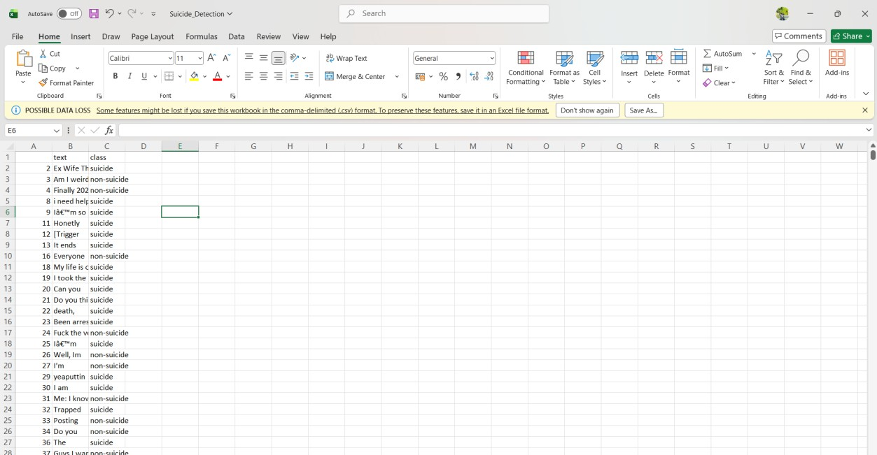

Label Categories

Label | Description
Safe | Normal conversational or emotional messages
High Risk | Crisis, self-harm, suicidal, or emergency intent messages

Sample Dataset Records

Input Text | Label
I feel stressed about exams | Safe
I feel okay today | Safe
I don’t want to live anymore | High Risk
I wish everything would end | High Risk

Preprocessing Performed

- Duplicate data removed

- Text normalization applied

- Tokenization performed

- Labels balanced

- Converted into embedding format for model training

Project Images



Booking page Chatbot page



Home page Peer Page



Resources Page

Git Hub Link

https://github.com/varunbantia/mental-health-system

Research Paper Submission
